Linking strategy and evaluation in the public sector

Paper for the conference "What's new and what works in the EU cohesion policy 2007-2013: discoveries and lessons for 2014-2020"

3-4 March 2011, Vilnius, Lithuania

Benedict Wauters

3 March 2011

Abstract:

The paper puts forward that the key to integrating evaluation into the strategic management of public sector organisations lies in integrating the Balanced Scorecard (BSC) strategic management system with the concept of “theories of change” as used by evaluators. This theoretical framework is expected to be capable of capturing the strategy of any public sector organisation and even provide suggestions for improvement of the strategy. It is applied to the case of the Flemish European Social Fund Agency and draws on the work of evaluators in proposing theories of change for the Flemish ESF Operational Programme.

Balanced Scorecard; logic model; evaluation; public sector; results based management; theory of change; objective setting

Table of contents

1. Building a new framework for public strategic management 4
1.1. Introducing the Balanced Scorecard framework for the public sector 4
1.1.1. Legitimising authorities instead of shareholders 5
1.1.2. There is no simple concept of “customer” for the public sector 6
1.1.3. Interests of a multitude of stakeholders need to be balanced much more in the public sector 9
1.2. Introducing logic models 10
1.3. Integrating logic models and Balanced Scorecards 19
2. Using the new framework as a tool for strategic management 23
2.1. Coordinating multiple instruments (horizontal coordination) 23
2.2. Coordinating multiple stakeholders 25
2.3. Cascading strategy between hierarchical levels of the public organisation (vertical coordination) 26
2.4. Linking strategic management and evaluation 28
3. Case study: analysis of the strategy of the European Social Fund Agency of Flanders 32
3.1. The Flemish ESF Agency case 32
3.2. Coordinating multiple instruments and stakeholders 32
3.3. Cascading the map 36
3.4. Linking evaluation and strategic management 36

List of figures

Figure 1: Standard private sector BSC 5
Figure 2: example logic model of intervention for a health programme 10
Figure 3: Programme chain of events 13
Figure 4: Reformulating the World Bank example 14
Figure 5: Circles of influence 16
Figure 6: theory of change of World Bank example 18
Figure 7: two logic models corresponding to two different theories of change 19
Figure 8: strategy map 20
Figure 9: link between BSC and logic model 21
Figure 10: reduced BSC 24
Figure 11: stakeholders in the BSC 25
Figure 12: cascading in a mixed example 27
Figure 13: single and double loop learning with the BSC 29

List of tables

Table 1: progress markers in outcome mapping 17

“In the private sector organisations results are judged by the market. If this market is absent or not functioning according to the rules of competition, as is the case for many public sector organisations (including policy ministries, regulatory agencies, service providers etc.) then evaluation becomes a necessity and in many cases an obligation” (EC, 1999, p. 17).

In the private sector, tracking whether shareholder value is being created is fairly easy. Even if a company is not listed on the stock market, the financial drivers are well known and an estimate of value can be derived. Likewise, tracking customer satisfaction is relatively easy.

In the public sector, however, the job of assessing whether public value has been created is in many cases the domain of evaluators. These tend to perform two major functions (EC, 1999):

- to ensure accountability of the organisation by providing an independent judgement on the performance of the organisation (referred to as summative evaluation);
- to improve the functioning of the organisation (formative evaluation).

However, the threat of a harsh judgement by the market does not mean that private sector organisations all perform equally well. Indeed, by the time the market pronounces it judgement, it is in many cases too late to still remedy the situation and improve performance. This has highlighted the necessity to think strategically, to translate this strategy into daily operations and to engage in learning exercises to ensure a flawed strategy is not maintained too long.

Similarly, in the public sector, evaluation may well be a substitute for the market in terms of judging performance, but if it is not integrated within the strategic management system of the public organisation, at best, some of the recommendations will be implemented but the organisation will not put an ongoing reflection concerning what it aims to achieve and how it aims to do this at the core of its daily operations. This makes many evaluations an expensive but ultimately marginal exercise.

This paper will put forward that the key to integrating evaluation into the strategic management of public sector organisations lies in integrating the Balanced Scorecard (BSC) strategic management system with the concept of “theories of change” as used by evaluators.

The theoretical framework will then be used to describe and analyse the (implicit) strategy of the Flemish European Social Fund Agency. It is expected that the framework is indeed capable of capturing this strategy. In order to do this, the paper draws on the work of evaluators in proposing theories of change for the Flemish ESF Operational Programme.

Building a new framework for public strategic management

Introducing the Balanced Scorecard framework for the public sector
In order to be able to do this, the standard BSC as it is used in the private sector first needs to be adapted to three specificities of the public sector:

- The ultimate finality of the public sector is not shareholder value;
- The concept of “customer” is not as monolithic in the public sector as it is in the private sector
- Public sector organisations are confronted with many different, influential stakeholders, whose objectives may be conflicting, in contrast to the private sector where, under normal competitive conditions, customers, as recipients of goods and services, tend to provide the primary focus.

The following section will first expand on the issue of not having shareholders.

Legitimising authorities instead of shareholders

Balanced scorecards have been widely implemented in the private sector. The standard framework is visualised in Figure 1 (adapted from Kaplan and Norton, 2001, p. 77). The reasoning of the scorecard is as follows. Knowledge and skills of employees and the resources that support them are the basis for all innovation and improvements (learning and growth perspective). Skilled, empowered employees will improve the ways they work (process perspective). Improved work processes will lead to increased customer satisfaction. Finally, increased customer satisfaction will lead to better financial results (financial perspective). This puts shareholder value (and similar measures) firmly at the top of the BSC.

Figure 1: Standard private sector BSC
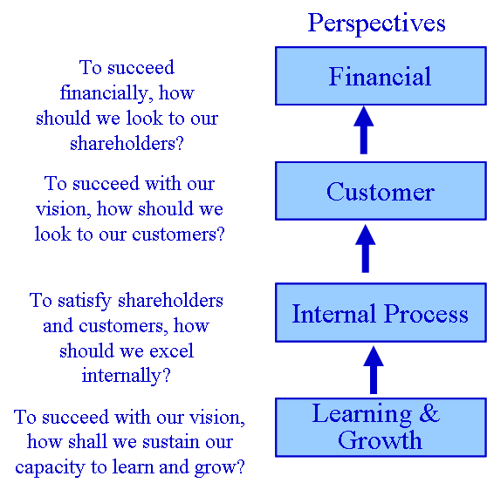

In the public sector, many organisations that have implemented a BSC, felt compelled to change the logic of the BSC to take into account that the ultimate finality of the public sector is not financial shareholder value. Kaplan and Norton (2001, p.135 ) propose to put overarching, long-term objectives at the top of the BSC: “Placing an over-arching objective on the BSC for a non-profit or government agency clearly communicates the organisation’s long-term mission”.

Of course, it should be understood that these longer term objectives of the public sector organisation are not defined solely by the managers of the organisation. Instead, each public sector organisation has “political” masters who ultimately legitimise the public organisation by providing its mandate. They generally want the organisation to contribute to their “policy” objectives and to do this for the smallest possible budget. The public organisation depends on its legitimising authority to receive a budget to run and/or expand operations to fulfil its mandate, next to any revenue streams that may come from paying “customers” or other sources. This applies for example when public sector “utilities” (e.g. public transport), have to take account of political priorities that may not make much sense from a financial profitability perspective (e.g. requiring to maintain servicing of railway lines that are inherently unprofitable to fulfil the policy objective of equal access to transportation) and receive an extra budget for doing that.

Therefore, instead of the financial perspective, which in the private sector reflects the interests of the shareholders, the public sector BSC should incorporate a legitimising authority perspective, that indicates the interests of the political masters (be they ministers, cabinets, boards or parliamentary committees) of the organisation, and ultimately, the electorate –the real “shareholders” of the public sector- they represent. Losing the support of these political masters would in many cases imply losing funding and/or mandate and hence shutting down or scaling back operations.

It is important to understand that in practice the legitimising authority will be interested in shorter term objectives as well and may even only focus on those. Most of these shorter term objectives would belong in another perspective (e.g. processes) of the BSC. It is then crucial for the public sector organisation to engage in a discussion with its legitimising authority that does focus on identifying the longer term objectives for the organisation and to keep the discussion on the other BSC perspectives firmly within the context of these longer term objectives. The management of the public organisation should ideally retain the initiative in proposing the right strategy to reach the longer term objectives. Whether it is the right strategy will have to be evaluated at a later stage.

In addition, it is often not desirable to publicly include some of the more personal objectives of (some) legitimising authorities in a BSC e.g. good press coverage for politicians. However, there is no need for conflict between legitimate objectives and these more personal objectives: being able to report real advances towards policy objectives will ensure good press coverage as well. That coverage may even provide a good indicator of progress in terms of the longer term objectives.

That funding also comes from payment by customers for goods and services, does not imply that these are the legitimising authority. To find out who is the legitimising authority requires determining who everyone looks to for (political) priorities and who can decide to withdraw a mandate. This can involve more than one actor (e.g. parliament, ministers, committees…). Hence, the legitimising authority perspective is the result of a negotiation process with all concerned actors.

Next to not having shareholders, this article is drawing attention to the fact that the term “customer” can take on a variety of meanings in the public sector. The next section covers this.

There is no simple concept of “customer” for the public sector

The state has different relationships with its constituents as has been recognised by Henry Mintzberg (1996) who distinguishes four different types:

- “Customer”: here goods and services are provided, that are accessed through market mechanisms in competition with the private sector. Very little of what the state does, in a free market economy, falls within this category. This tends to be the domain of the private sector that tries to sell as much as possible, maintaining an arm’s length relationship controlled by the forces of supply and demand;
- “Client”: in this case, professional services and facilities such as health care, education, public transport are provided. The organisations providing this type of services should not be in the business of inciting to consume as much as possible of these services beyond what is necessary from a societal perspective. Nor is it a good idea to provide access solely through market mechanisms (price) as these services should be accessible up to a minimum level to everyone, regardless of the financial resources these “clients” could muster. These services may be funded in large part by the state, but their ownership and provision can be the domain of non-profit organisations or cooperatives;
- “Citizen”: this refers to the provision of physical (such as roads and ports), social (such as museums and parks), mediating (such as civil courts) and economic infrastructure (e.g. monetary policy) as well as the infrastructure of democracy (e.g. election machinery) and government itself (e.g. embassies). Of course, the state may own the infrastructure, but private or non-profit organisations can be used to finance, design, build, operate and maintain it, in return for future revenue streams (e.g. through a concession or another form of public private partnership as is frequently the case with roads).
- “Subject”: this is the job of regulating and controlling (e.g. to ensure societal actors act appropriately or adopt a proper attitude) as performed by the police, military, prisons, judiciary and regulatory agencies. Although making the laws and rules clearly is the role of the legislative branch of government, supported by their relevant government departments, carrying out enforcement duties could be outsourced to private and non-profit actors. However, as with the activities under “citizen”, the state should remain the “owner”.

Mintzberg (1996) also makes it clear that some activities engaged in by the state do not fit neatly in one of the four categories. For example, a national park can provide customer services to tourists, client services to tourist stranded on the top of a mountain, while providing a public infrastructure to be enjoyed by citizens and a requirement toward subjects to respect the environment. It is therefore clear that it is useful to disaggregate an organisation’s vision and mission (statement where the organisation wants to be in a given number of years and what its primary purpose is) to determine the nature of its relation with its different types of constituents.

However, within the above classification, the relation between the constituent and the public sector organisation in terms of “subject” poses a particular challenge to conventional BSC thinking. In this case it is the public sector organisation that expects something from the constituent, rather than the other way around. Indeed, having to accept grades from a teacher in school, for example, is clearly of a different nature than expecting trains to be on time. If one would ask a student what would satisfy him/her, then the reply may well be that they expect a high grade. Nevertheless, no one would dream of reprimanding a lecturer for not giving high grades just to please the students. On the contrary, severe but just marking is what earns respect in education.

The performance prism, in contrast with the standard public sector BSC, offers a different perspective on this by suggesting to systematically state what the public sector organisation hopes to receive from a stakeholder (be they constituents, partners, supplier, legitimising authorities, employees etc.) as well as what it offers to them (Adams, Neely and Kennerley, 2002). Systematically addressing this ensures that there is a focus on value for both sides at all times. This is all the more true of “subjects”. Whereas subjects may, for example, be expected by the state to comply with the law, they are also entitled to expect a fair process to judge them when they have broken it. “Give” and “gets” can be fitted easily in the causal logic of the BSC: for example, in order for the subject to give something, there needs to be something offered first by the public organisation.

Based on the above sections and on the work done by Adams, Neely and Kennerley, 2002, it is now possible to compose a generic list of stakeholders that could be important to any public organisation, together with what they can bring to the public organisation, as well as what they might want from it:

- Customers:
  - They want right (high quality), fast (rapid/reliable delivery), cheap (price reflects value), easy (low hassle, good selection to tailor for specific needs) services/goods they can use, with branding that reflects their aspirations;
  - The public organisation may want buyer loyalty and opinion (through feedback / suggestions to improve), and , where appropriate, also growth and profit;
- Clients:
  - Clients care about good relations with the service provider who is knowledgeable about the client’s needs, solutions oriented and offers pricing that does not hinder essential access to the services (meaning it is either for free or affordable to all);
  - The public organisation requires trust (e.g. access to key information) and a strong and positive image as well as support for the aims of the organisation with a willingness to establish longer term relations (not fixed on short term satisfaction);
- Citizens:
  - They want general well-being and wealth as well as integrity (public organisations in general should be open, honest, responsible) from the public organisation
  - The public organisation wants in return broad public recognition and support.
- Subjects:
  - A subject wants to have rules (to ensure it will not be disadvantaged), reasons (rules that have a sound purpose and are reasonably implementable), clarity (unambiguous rules) and advice;
  - The public organisation wants to see legal (compliance), fair (eg not anticompetitive), safe (not endangering anyone) and true activities (say what they do and do what they and their products say).

The various expectations listed above are also reflected in the idea of “public value” as defined by Kelly, Mulgan and Muers (2002). Public value incorporates different elements that are worth something to customers, citizens, subjects and /or clients:

- Value created directly by services (e.g. transportation);
- Value of fairness in service provision: this denotes the value associated with appropriate access and can in many cases be linked to legislation (e.g. basic education for all);
- Value of outcomes: this is, for instance, the value of safety from crime, which goes beyond just having quality police services;
- Value of trust and legitimacy: if the public sector is caught lying or engaged in fraud and corruption, this diminishes its value in the eyes of the citizen, regardless of the level and fairness of service provision or outcomes.

To conclude, rather than a “customer” perspective, the public sector requires a broader “constituent” perspective. This is also in line with Epstein et al. (2001) who put forward a “good corporate citizen” strategic theme that, while covering all four perspectives of the BSC, also includes in the customer perspective what communities and society in general expect from an organisation. Items such as “product safety”, “green products”, “advertising complaints” etc., as listed by Epstein et al. (2001), clearly fit within the previously mentioned expectations of the various kinds of constituents.

At the start of this article, the statement was also made that not having “shareholders” and not having a simple concept of “customers” did not constitute the only difference with the private sector. In addition, the balancing of the interest of multiple stakeholders is also much more pronounced than in the private sector. The following section expands on this.

Interests of a multitude of stakeholders need to be balanced much more in the public sector

Multi-stakeholder strategies are at the core of the previously mentioned “performance prism” framework (Adams, Neely and Kennerley, 2002.).

The performance prism adds suppliers and partners to customers and community in a “stakeholder”, rather than a customer perspective. In the BSC these first two actors are usually relegated to the process perspective.

In a public sector context, it may be necessary to be more attentive to suppliers and partners and to direct some processes within the organisation towards keeping these actors, next to constituents, satisfied,. Of course, the private sector often also has to take into account interests of partners and suppliers, however, these will rarely compete with the need to satisfy customers as they do for the public sector.

For example, dealing with the expectations of partners such as employee and employers organisations (commonly referred to in Europe as the “social partners”) is a necessity for many public sector organisations. Addressing the relation with these and other “partners” is often not optional. The same goes for other kinds of interest group (e.g. environmental, social, etc.).

As to the relation with suppliers, this is, for example, crucial for the armed forces. A relation of trust and confidentiality needs to be established for suppliers to be able to innovate and deliver better performing equipment for the military to use. Of course, the supplier also wants to create revenue out of it.

It is clear that in the public sector the “constituent perspective” defined in chapter 1.1.2 would regularly need to be balanced with other interests. The performance prism suggests to put these other stakeholders on a par with the customers. However, this would disrupt the cause-effect logic visible in the BSC (Kaplan R.S., 2008). Therefore, it is better to explicitly highlight such stakeholders concerns in the process perspective as proposed by Kaplan and Norton (2001). Ascertaining how to deal with stakeholders can be done with formal stakeholder analysis.

In addition, like with the constituent perspective, care should be taken to explicitly identify expectations to and from suppliers and partners as defined by Adams, Neely and Kennerley (2002):
- Suppliers:
  - Suppliers want from their clients revenue growth, productivity (e.g. for their own shareholders), loyalty, opinion and trust;
  - The public organisation in turn wants to be treated like a client by its suppliers;
- Partners: both parties want mostly intangibles like skills, knowledge, technologies, brand, channels, networks, loyalty and trust.

In the BSC causal logic, satisfying what suppliers and partners expect from the public organisation can be seen as causes for satisfying what the public organisations expects. If it is not attractive to work with the public sector, then the public sector will not meet its own expectations. The same goes for constituents: if the public organisation does not meet their expectations first, it cannot expect anything in return.

Notice should be taken of a special case: sometimes the public sector organisation depends on channelling funding to “intermediaries” to make sure that the general public can access appropriate public services. For example, most government grant programmes operated by funding agencies that use calls for proposal operate with such intermediaries (e.g. a training provider to provide job training to job seekers). These intermediaries are often called “delivery partners”. However, they differ from standard partners as they tend to be paid (like a supplier) for performing certain activities which the agencies lack the capacity or authority to perform themselves. They are not standard suppliers either as they do not supply anything that the funding agency uses itself in its own processes. They receive funding for helping the agencies reach their actual constituents. As the relationship is ultimately intended to serve the public organisation’s final group of constituents, these intermediaries should be placed in the BSC in the process perspective below the constituent perspective.

The concept of making cause-effect linkages explicit is however not a new one for the public sector. The next chapter explores how the public sector has dealt with this long before the advent of BSC strategy maps.

Introducing logic models

Evaluators working within the public sector are well acquainted with the concept of the “logic model” (Kusek and Rist, 2004; European Commission, 2007; Saldanha C.D. and Whittle J.F., 1998) which has been refined since the 1950ies (Solem, 1987).

Figure 2 shows an example of a logic model as put forward by the World Bank (adapted from Kusek and Rist, 2004). In essence a logic model displays the objectives of an intervention in a causally related way.
Figure 2: example logic model of intervention for a health programme
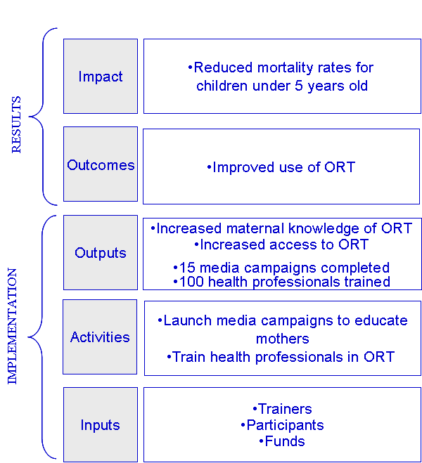

ORT=oral rehydration therapy

In the World Bank example, both “15 media campaigns launched” as well as “Increased maternal knowledge of ORT” qualify as outputs which are defined as “the products, capital goods and services that result from a development intervention; these may also include changes resulting from the intervention which are relevant to the achievement of outcomes” and are considered part of the implementation of an intervention.” Outcomes like “improved use of ORT” are defined as “short-term and medium-term effects of an intervention’s outputs.” Impact goals like “reduced mortality rates” are defined as “positive and negative, primary and secondary, long-term effects produced by a development intervention, directly or indirectly, intended or unintended.” Outcomes and impact together are referred to as results (Kusek and Rist, 2004). OECD-DAC (2002) uses the same definition with as only difference that “results” includes outputs as well.

EU Structural Funds use a similar terminology with inputs, activities and outputs belonging to implementation and two levels of effects following from the outputs (EC, 1999).

More specifically, “An output is considered to be everything that is obtained in exchange for public expenditure. Outputs are normally under the entire responsibility of operators who report on them through the monitoring system. Examples of output indicators include: kilometres of roads built; progress rate of the building of a road; hectares of urban wasteland rehabilitated; capacity of purification plants built; number of trainees whose training was paid by the programme; and percentage of this training of which the quality is certified.” (EC, 2007).

The first level of effects is referred to by EC (2007) as “result” (instead of outcome as in the World Bank case) and the second level as “impact”. “Result indicators represent the immediate advantages of the programme (or, exceptionally, the immediate disadvantages) for the direct beneficiaries. An advantage is immediate if it appears while the beneficiary is directly in contact with the programme. The full results may be observed when the operator has concluded the action and closed off the payments. Result indicators are generally easily known to the operators, so they are generally quantified during monitoring. Result indicators provide information on changes which occur for direct beneficiaries, for example, time saved by users of a road; reduced rates for telephone calls; qualifications earned by trainees; new tourist activity generated by a farmer; use of new productive capacity created by a firm; and the satisfaction of businesses which have received consultancy services. It is at the time that beneficiaries receive support or programme services that results can be quantified. Either direct measurements are made (e.g., by counting the number of trainees recruited during their training) or the direct beneficiaries are asked to state the advantages they have obtained (e.g., by means of a questionnaire at the end of a consultancy mission).”. To avoid confusion in this paper, the term “outcome” will also be used to refer to “results” as defined by the EC.

“Impact indicators represent the consequences of the programme beyond its direct and immediate interaction with the beneficiaries. An initial category of impacts group together the consequences for direct beneficiaries of the programme, which appear or which last into the medium term (specific impacts), e.g., traffic on a road one year after it is opened; the placement rate of trainees after twelve months; sustainable jobs created in an industrial plant built with programme support; and the survival rate of businesses created with programme support. Some impacts are unanticipated (spin-offs) but indicators are rarely created for unanticipated impacts. A second category of impacts consists of all the consequences that affect, in the short or medium term, people or organisations that are not direct beneficiaries (EC, 2007).

Common to the two approaches is that outputs and outcomes are distinguished in terms of implementation versus consequences of implementation. This is in line with OECD (2009) which states that it is reasonable to hold government responsible for outputs but not entirely for outcomes as many other factors beyond government’s control may influence the latter. Implementation is supposed to be under control while consequences are intended but cannot be ensured.

In addition, both approaches use two levels of consequences of implementation. However, Kusek and Rist (2004) distinguish the first level from the second one by means of the moment these consequences become visible (short and medium term versus longer term) whereas EC (2007) distinguishes them according to the interaction of participants with the intervention (consequences appearing for beneficiaries while in direct contact with the project versus effects appearing –not only for direct beneficiaries- beyond this direct contact). Of course, there is a link with the World Bank approach as interaction happens in the short term and anything soon after that would be classified as short or medium term.

One of the implications of these small differences in definitions is that in the World Bank example having launched campaigns (products) and mothers being more knowledgeable (changes resulting from the intervention which are relevant to the achievement of outcomes) are both classified under outputs. For the EC, mothers being more knowledgeable would rather be considered as an immediate advantage, appearing while the beneficiary is directly in contact with the intervention. It would not be considered as something “obtained in exchange for public expenditure, under the entire responsibility of operators”. For example, how knowledgeable the mothers that participate in the programme will be, depends in part also on the willingness and capacity of these mothers to learn.

Both approaches pose difficulties. Regarding the World Bank approach, besides the relatively vague boundary between outputs and outcomes due to the inclusion of “changes resulting from the intervention which are relevant to the achievement of outcomes” under the definition of outputs, there is no common understanding of what is short, medium or long term in terms of outcomes.

Regarding the EC approach, “improved access to ORT” could be both “obtained in exchange for public expenditure, under the entire responsibility of operators” as well as an “immediate advantage appearing while the beneficiary is directly in contact with the programme”. In the EC approach, the concept of “beneficiary” interaction also may cause some confusion: a participant (e.g. a mother) may not actually be the intended beneficiary (e.g. children) of the intervention but rather an intermediary actor. In this paper, to avoid confusion, the term beneficiary will be reserved for final target groups, end users or ultimate beneficiaries. These may, or may not be the actual participants. However, a beneficiary can only be a beneficiary if there is a link between someone who participated and this beneficiary.

Additionally, what is missing in both the World Bank and the EC approaches is a clear definition of the nature of outputs versus the various types of outcomes/results that also takes into account the difference between participants and intended beneficiaries.

A first step in the right direction is provided by Patton (1997) who defines a hierarchy of programme design (see Figure 3 on the left hand side) that can be extended to any intervention. Figure 4 shows how applying the framework will lead to substantial changes.

Figure 3: Programme chain of events
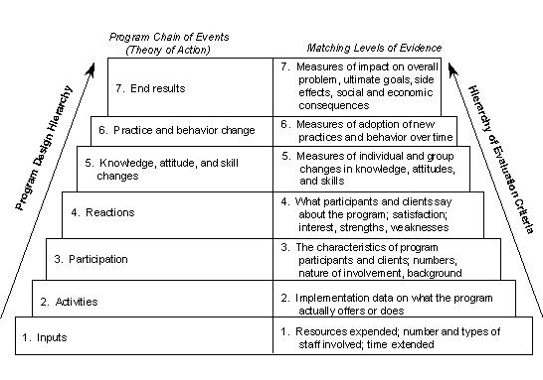

Steps 1 to 4 in this hierarchy clearly relate to implementation. What becomes clear here is that launching media campaigns probably requires the input of some kind of campaign specialist.

Steps 3 and 4 relate to participants. Defining outputs in the framework entails being able to say what (various types of) participants receive in what way and how satisfied they are with this. This means that in the World Bank example, the output would have to be reformulated to make clear in which ways different types of mothers (e.g. differentiated according to background) acquire knowledge concerning ORT. Rather than “media campaigns completed” this would entail determining as output the numbers of mothers that have been reached with the media campaigns. Running the campaigns is then part of the activities. Ideally, a particular level of satisfaction of the mothers with the campaigns they have been exposed to would also be part of the output description. The 100 trained professionals also fit in Patton’s hierarchy if we add to it that they have completed the training. Again here, a qualitative component in terms of the varying nature of the training and types of the trainees as well as their satisfaction with the training needs to be added.

Steps 5, 6 and 7 refer to consequences of implementation. The hierarchy assumes that before people and institutions behave differently, their knowledge, skills and attitudes have to be affected first. However, it may also be possible that a change in practice is enforced (e.g. by enacting legislation on non-discrimination) without attitudes having changed first. In any case, without changes in how people and institutions behave, there can be no end results in terms of social and economic consequences.
In the World Bank example knowledgeable mothers are clearly an intended outcome, derived from exposure to the campaigns. Their behaviour change will be to make improved use of ORT. Patton’s hierarchy also requires making the outcome of the trainings for trainees, in particular the level of knowledge they have obtained concerning ORT, explicit. Indeed, Patton’s framework requires to describe outputs and outcomes for any participant in an intervention, whether they be the intended beneficiary or not. In the example, the project funds the training and then assumes that these trainees will afterwards be available to help mothers. The “access to ORT” therefore is an outcome that depends on the earlier outcome of increased skills. Actually, it would be better to reformulate access to ORT as “health professionals provide ORT” as this clearly denotes a behavioural change.

It should then also be clear that another behavioural outcome is missing: mothers have to go to these health professionals more for ORT administration when needed and if they cannot administer it themselves. This is again a behavioural change expected to derive from the knowledge these mothers have acquired.

While Patton’s hierarchy helps to distinguish outputs from outcomes by focusing on participants in the intervention which are to be defined as those that actually come in contact with the funded activities, the ultimate fate of the intended beneficiaries of the intervention seems to be lumped up in step 7 of the hierarchy. Clearly, these intended beneficaries need to be in the picture more. In order to do this, it is important to clarify the concept of beneficiary “needs”.

Figure 4: Reformulating the World Bank example
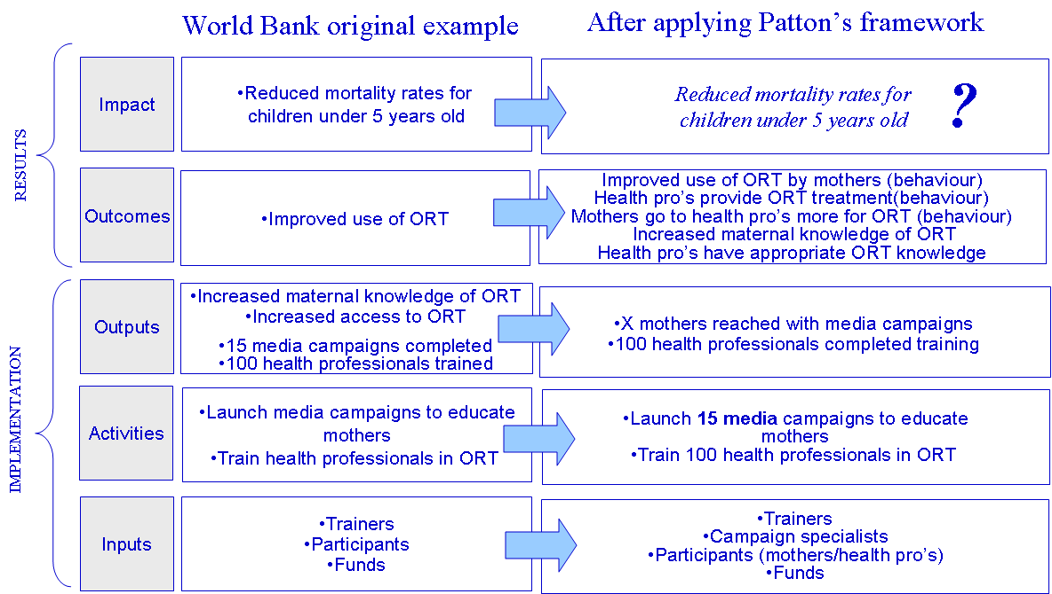

EC (2004) uses a level of consequences, not present in the World Bank and Structural Funds logic models, that provides a good starting point. It is referred to as the “project purpose” and defined as “The central objective of the project. The Purpose should address the core problem(s), and be defined in terms of sustainable benefits for the target group(s).”. Clearly, sustainable benefits for intended beneficiaries should be at the core of any intervention. It is what makes them relevant. EC (2004) accordingly defines relevance as “The appropriateness of project objectives to the real problems, needs and priorities of the intended target groups and beneficiaries that the project is supposed to address.”. In our World Bank example, these are the children. The benefit for these children seems to be that they do not die from dehydration (itself linked to children’s diarrhoea). Sustainable means that the benefits do not disappear when intervention funding ends. In the example, this means that the knowledge that women have acquired and the skills that health practitioners have gained keep translating into women using the offered services after the intervention has ended.

Of course anything in the project can be interpreted as being a “benefit”. Therefore, it is necessary to make clearer what is meant with this concept. When trying to better understand the meaning of “benefits” for target groups, yet another model is of assistance. Most organisational development professionals are familiar with the “hierarchy of needs”, first developed by Maslow (1997):

- Primary physiological needs concern sustenance needs, needs to be active, to rest, to sleep, to avoid pain, etc.
- The safety and security needs concern finding safe circumstances, stability, protection as evidenced by a need for structure, order, limits. Examples are having a home in a safe neighbourhood, a degree of job security, a good retirement plan, insurance, etc.
- The belonging needs concern the need for friends, a family, affectionate relationships in general, a sense of community. Examples are getting married, being member of a church, a part of a gang or a bowling club. It is also a part of what we look for in a career.
- The esteem needs: the lower esteem need is the need for the respect of others, the need for status, fame, glory, recognition, attention, reputation, appreciation, dignity, dominance. The higher form involves the need for self-respect, including such feelings as confidence, achievement, mastery (closely linked to competence but not referring to mere knowledge or skills but to excellence in them), independence, and freedom. Note that this is the “higher” form because, unlike the respect of others, once you have self-respect, it is difficult to lose.

Maslow (1997) has used a variety of terms to refer to the next level: growth motivation (in contrast to deficit motivation), “being” needs and self-actualization (seeking personal growth and peak experiences). They involve the continuous desire to fulfil one’s potential.

Although the hierarchical nature of Maslow’s theory can be criticised, it remains a useful descriptive framework. Any real benefit for target groups, as described earlier, can always be connected to one or more of these types of needs as they are intrinsic needs. This means real benefits do not reflect needs that are only means on the way to satisfaction of more fundamental needs. Rather, benefits should focus directly on these fundamental needs e.g. gaining knowledge may be derived from a more fundamental need to excel and be recognised for it (esteem needs). It may also serve to get a first job (security need). There are many uses for knowledge. However, the needs as expressed by Maslow’s hierarchy are worthwhile for people in their own right. They are what constitutes the overall well-being of people. The use of Maslow’s hierarchy makes clearer what is now encapsulated in Patton’s seventh step: social and economic consequences and impact on the overall problem.

Maslow’s hierarchy also points to the fact that one cannot just pick any one outcome for an abstract target group e.g. “the unemployed”. The level of needs that sub-groups are occupied with may vary greatly e.g. long term unemployed may have needs connected to basic security that for them are more pressing than getting a job. So it makes sense to start with needs assessments for a specific target group first when drawing up an intervention logic.

However, Maslow’s hierarchy does not capture everything that is part of Patton’s seventh step. Fulfilling the needs of beneficiaries has to be put within a wider context of policy objectives. “Children dying less from dehydration” is not the same as “reducing mortality rates” as first, children die of many more causes than dehydration and second, the mortality rate considers not just the children of “participants” (mothers who saw the campaigns) but of the entire population. Yet it is the mortality rate that concerns policy-makers first and foremost and that is labelled as impact of an intervention.

Therefore the concept of “impact” in the logic model needs to be further explored. Both EC (2009) and World Bank (2004) distinguished this concept from “outcomes” by saying this concerns the longer term consequences. However, as already stated, it is not clear what “longer term” really is. Is “not dying from dehydration” long term enough to be qualified as an impact or is it short term enough to be an outcome? Furthermore, the mortality rate at a national level is clearly less relevant to the intervention in the World Bank example than the amount of children dying from dehydration.

It may be more practical to use Montague’s (2000) concept of various circles of influence ranging from elements that can be controlled, directly influenced and indirectly influenced (Figure 5). In the World Bank example, the intervention is directly influencing mothers and health professionals. However, it is not in direct contact with children themselves. Therefore, “children dying less from dehydration” is in the circle of indirect influence. Depending on whether an intervention is in direct contact with the intended beneficiaries or not, their needs will be represented in the circle of direct or indirect influence. In the World Bank example, the health professionals themselves are not staff within the project. They are only participate in a training and what they choose to do after the training is entirely up to them. So while they are directly influenced by the project, this also means that the project only exerts indirect influence on the children.

Figure 5: Circles of influence

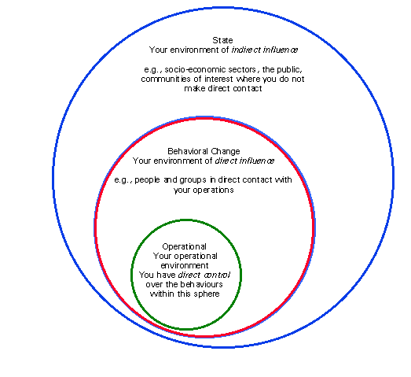

Direct versus indirect influence is clearer as a concept to provide for a distinction between outcomes and impact than time horizon is. In line with this approach EC (2009) states that “impact indicators represent the consequences of the programme beyond its direct and immediate interaction with the addressees or recipients.” Applied to the example, less children dying of dehydration would be an impact (indirect influence) while consequences at the level of mothers and health professionals are outcomes.

This approach towards distinguishing outcomes and impact is in line with the more recent intervention planning, monitoring and evaluation methodology referred to as “outcome mapping” (Roduner et al. 2008). Outcome mapping puts its focus on making very clear what is expected of intermediate target groups that receive project outputs, but that are not the intended final beneficiaries themselves. These intermediate target groups are referred to as “boundary partners” and expectations towards them are referred to as “outcome challenges” that describe the changed behaviours (relationships, activities, and/or actions) of a partner; and how they would be behaving if they were contributing ideally to a pre-defined vision (Roduner et al. 2008). Measuring progress towards these challenges is done by a set of progress markers defined as “a gradual set of statements (milestones) describing a progression of changed behaviour in a partner”. This means outcome mapping does not use indicators as such to measure progress at the level of partners, but rather qualitatively described milestones (see Table 1).

Table 1: progress markers in outcome mapping
Outcome Challenge for local communities:

The program intends to see local communities that recognize the importance of, and engage in, the planning of resource management activities in partnership with other resource users in their region. These communities have gained the trust of the other members of the partnership and the recognition of government officials so that they can contribute constructively to debates and decision-making processes. They are able to clearly plan and articulate a vision of their forest management activities and goals that is relative to their context and needs. They call upon external technical support and expertise as appropriate. They act as champions for model forest concepts in their communities and motivate others in the partnership to continue their collaborative work.

EXPECT TO SEE LOCAL COMMUNITIES:
1 | Participating in regular model forest (MF) partnership meetings
2 | Establishing a structure for cooperation in the partnership that ensures that all local interests are represented (mechanics of setting up the structure)
3 | Acquiring new skills for involvement in the MF
4 | Contributing the minimum human and financial resources necessary to get the MF operational
LIKE TO SEE LOCAL COMMUNITIES:
5 | Articulating a vision for the MF that is locally relevant
6 | Promoting the MF concept and their experiences with MFs
7 | Expanding the partnership to include all the main forest users
8 | Calling upon external experts when necessary to provide information or meet technical needs
9 | Requesting new opportunities for training and extension
10 | Producing and disseminating concrete examples of benefits arising from MF activities
11 | Identifying opportunities for collaboration with other institutions and actors
12 | Identifying opportunities for, and successfully obtaining, funding from a range of sources
LOVE TO SEE LOCAL COMMUNITIES:
13 | Playing a lead role in resource management with view to long- and medium-term benefits
14 | Sharing lessons and experiences with other communities nationally and internationally to encourage other MFs
15 | Influencing national policy debates and policy formulation on resource use and management
Source: Earl et. al (2001)

What is expected of local communities in Table 1 is under the direct influence of the intervention, but not under its control. In that sense, it is a description of the outcomes as defined earlier by using Montague’s (2000) concepts. The way these outcomes are described may look substantially different than what we usually consider to be an indicator, yet this can be the basis for a more traditional indicator system e.g. where an indicator that measures “degree to which expectations are met” can use the three levels described above to attribute values that reflect “does not meet expectations”, “meets expectations”, “exceeds expectations”, “greatly exceeds expectations”.

Having discussed the nature of the difference between outputs and outcomes as well as impacts one more source of confusion needs to be addressed: the difference between “impact”, as we have now defined it, and “context” indicators. EC (2009) also states that “context indicators apply to an entire territory, population or category of population – without distinguishing between those that have been reached by the programme and those that have not.” This clearly distinguishes “children die less of dehydration” from children’s “mortality rate” with the latter being a context indicator even though time horizons are equal. Impact indicators can be used to monitor interventions, even if the influence exerted is indirect and hence less attributable to the intervention. Context indicators should rather be used to identify strategic priorities by policy-makers to ascertain where there is a need for an intervention. Afterwards, it is well possible for an intervention to have considerable impact (e.g. children of mothers that were reached by the intervention die less of dehydration) while the context indicator stays stable or deteriorates (other mothers not touched by the intervention have not changed their behaviour and greatly outnumber the ones that were reached).

In order to fully grasp the nature of the influence that is exerted by an intervention it is also useful to introduce Chen’s (2005) concept of “theory of change”. This visualises the way the intervention is supposed to work as a causal theory. This has the advantage of making clearer than a logic model what the chain of influence looks like. Figure 6 shows, on the left hand side, that, if health professionals are merely influenced and not part of the intervention itself, only “mothers exposed” and “health pro’s trained” belong to “operational control” while consequences up until, but not including, “children are less dehydrated” are within direct influence. If, however, the intervention would also finance the ORT service delivery of the health professionals, they would be within the circle of operations and they would directly influence children as displayed on the right hand side.

Figure 6: theory of change of World Bank example
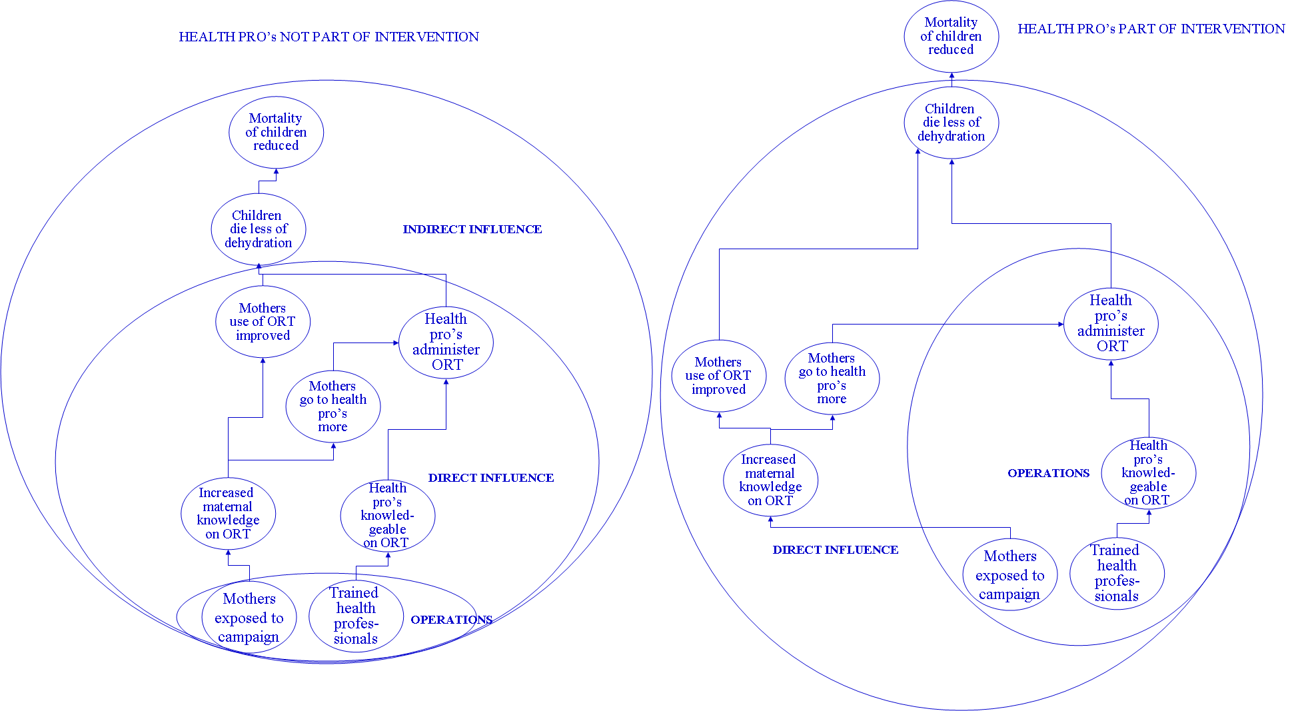

This distinction is not trivial as it links directly to the issue of accountability. In the example on the left hand side, managers of the intervention can only hope health professionals do a decent job delivering ORT services, while on the right hand side, it is the intervention manager’s job to make sure they do as it is within the sphere of operations. Clearly, the right hand project will be more expensive.

Theories of change can be translated into logic models. The two different theories of change displayed above should translate into different logic models. Figure 7 shows how this is indeed the case.
Figure 7: two logic models corresponding to two different theories of change
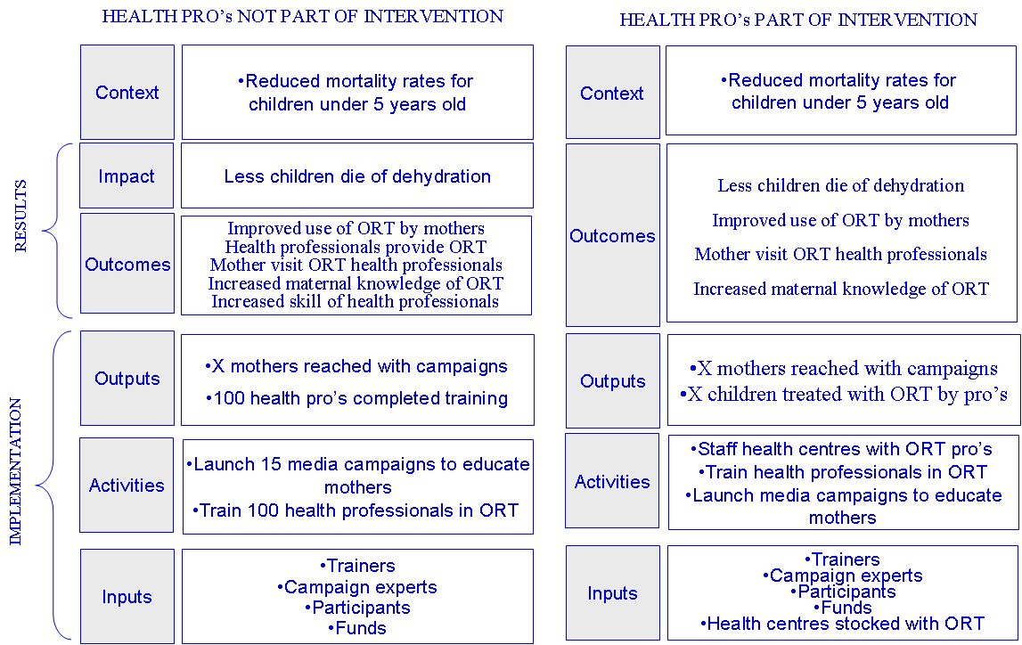

It also reveals a fundamental drawback of the way logic models are represented: the classification of ouput, outcome and impact is inherently linked to (types) of activities. The example on the right hand side classifies “less children die of dehydration” as an outcome because this is directly influenced by the staffing of health centres with ORT health professionals who belong to the project. However relative to the action “launching campaigns”, “less children die of dehydration” is still an impact. This cannot be captured by a classic logic model where an objective cannot be both an outcome and an impact. Theories of change, combined with circles of influence, do not have these drawbacks. To be clear, this does not mean that it is not useful to understand whether an objective is an output, an outcome or an impact, but this should always be relative to a particular action. In many logic models, all goods and services that can be produced, regardless of the actual influence the public organisation has on this production, are listed under outputs because the format of the logic model is not the best suited to display varying degrees of influences.

The question that remains now is if and how such a logic model / theory of change approach can be integrated in a Balanced Scorecard and what the added value of this is. This is discussed in the next chapter.

Integrating logic models and Balanced Scorecards

In order to construct Balanced Scorecards, Kaplan and Norton (2000a) propose to create a strategy map (see Figure 8) for an example as how this would be used in the private sector) that covers the four perspectives of the BSC. This map shows how objectives related to key success factors for realising a previously formulated vision and mission are causally linked within and between the various perspectives. Kaplan and Norton also advocate the use of “strategic themes” (essentially these are strategic priorities that tend to be tied closely to different internal processes) to reinforce alignment of the key success factors across the perspectives.

Figure 8: strategy map
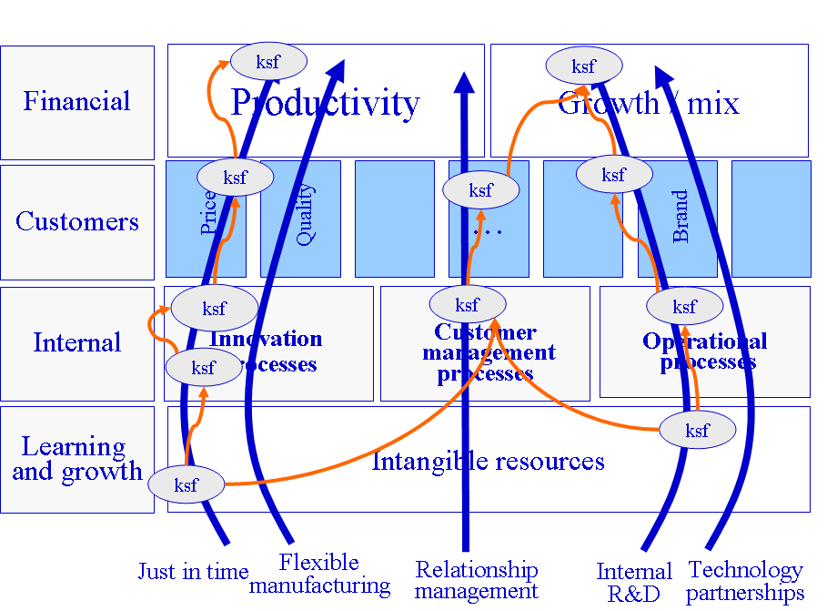

Rather than a neutral placeholder for a wide variety of (already available) indicators, a Balanced Scorecard is supposed to represent the strategy of an organisation devised to achieve its vision and mission.

It is at this point that Balanced Scorecard formulation can be greatly helped by connecting it to the previous discussion on logic models and theories of change. Clearly, theories of change and strategy maps are almost identical in nature. This means that we should be able to transpose strategy maps into logic models just as easily as we did theories of change.

Figure 9 shows that the legitimising authority perspective should always correspond to context objectives. The BSC constituent perspective however will correspond to a logic model differently according to the nature of the interventions being run by the public sector organisation.

If the organisation can only indirectly influence its intended beneficiaries (e.g. in the World Bank these are children), then the constituent perspective will correspond to impacts (e.g. “less children dying”) and to the outcomes which these beneficiaries experience (e.g. mothers and/or health professionals administering ORT to them). Part of the outcomes will be incorporated under internal processes as mothers can be considered a kind of partner collaborating with the public organisation if it concerns children’s health.

However, if there is direct contact with the intended beneficiary, then the constituent perspective will correspond to both outputs (e.g. ORT treatments administered by organisation personnel) and outcomes. In the latter case, there are no “impacts” at the level of intended beneficiaries, only context objectives, since there is no indirect influence towards these beneficiaries.

Input and activities always correspond to either the learning and growth or the process perspectives. In the organisation that actually employs health professionals and runs health centres, training the health professionals will be part of learning and growth rather than the process perspective as it concerns building internal capacity to execute processes. In addition, the strategy map reveals that there is a need for internal communication specialists which is also situated under learning and growth.

Financial resources which are an input in the logic model, are placed in the legitimising authority perspective, rather than in the learning and growth perspective, which, in conformity with the future oriented nature of the BSC, reflects that receiving more or the same level of funding is a direct consequence of achieving objectives.

The examples below concern an organisation that has only one context objective and that uses only two instruments (campaigns and trainings on the left hand and campaigns and health professionals on the right hand) to contribute to this objective.

Figure 9: link between BSC and logic model
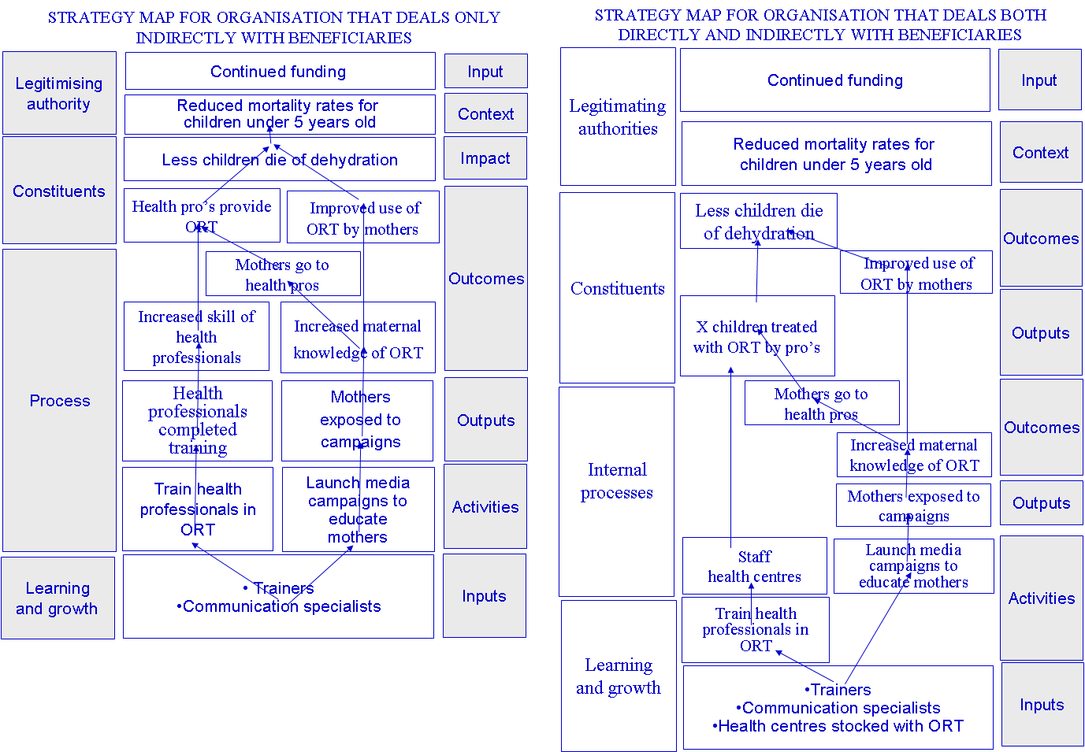

The added value of integrating Balanced Scorecards and logic models / theories of change derives from the different backgrounds of the two approaches. According to Lawrie et al. (2005), the BSC evolved as a tool for managers to articulate goals for themselves and to help the organisational centre to understand corporate (overall, at the level of the senior management team) performance and take action when required as well as to inform strategy evolution. As external reporting was covered adequately in the private sector by financial measures (profit, share prices etc.) the BSC evolved as a tool for internal consensus building and looking forward. A relatively limited amount of key success factors are derived from deconstructing a vision / mission statement sometimes connected to a SWOT analysis (strengths, weaknesses, opportunities and threats (see Johnson et al. 2008). Causal linkages are established across the perspectives of the BSC without understanding exactly how these linkages are supposed to work. However, the BSC does make very clear which stakeholders are involved in attaining objectives.

On the other hand, Lawrie et al. (2005) state that approaches connected to results based management, such as logic models and theories of change, focussed much more on the demands of external stakeholders (including donors in development aid) that achievement in areas of their interest be retrospectively demonstrated. Traditionally, this is done either through formal evaluations or monitoring systems which, taking specific funded activities as a starting point, require a more detailed understanding of the causal chain than the BSC. Consensus is also important in results based management but it is rather aiming for consensus between an organisation and an external party, than consensus within the organisation between managers.

By combining the BSC with results based management, they can draw on each other’s strengths, especially in a public sector context. The attention to detail and to the degree of influence public actors have that is the hallmark of logic models and theories of change can enhance the forward looking more managerially oriented BSC by moving it beyond “intuitive” and high level causal links. At the same time, the BSC, with its focus on the organisation rather than on each individual action provides for a more strategic orientation at the level of an organisation. This approach can reconcile the need for accountability towards external stakeholders, as well as ensuring that managers within the organisation are more engaged concerning the development and evaluation of the strategy of the organisation. As the BSC works with maps, it is more useful to use theories of change to support the BSC than it is to try to force them into the traditional logic model format. Finally, the clear stakeholder perspective is an advantage of the BSC when comparing it to standard logic models that are more concerned with classifying objectives as output, outcomes or impact than with managing the stakeholders that are necessary to achieve these objectives.

Having demonstrated that, conceptually, theories of change and the BSC can work well together, it is useful to also show the practical applications of this integrated concept. This concerns mainly vertical and horizontal coordination as well as a well-understood stakeholder approach. Finally, it also concerns using evaluation as a key component to make sure strategic learning happens. This is addressed further in the next chapter.

Using the new framework as a tool for strategic management

Coordinating multiple instruments (horizontal coordination)

The BSC can help to identify and further clarify how a variety of policy instruments at the disposal of the public sector organisation will contribute ultimately to context objectives.

Besides projects and programmes like the World Bank example (belonging to the broader ranger of subsidies) there are many other instruments available to the public sector: legislation and regulation (e.g. anti-discrimination laws), financial (dis)incentives (e.g. tax breaks, taxes, tariffs, interest and exchange rates) and investments (e.g. building roads). Implementing these instruments requires money and/or other (e.g. human) resources. The aim is of course always to influence actors in society to various degrees.

A non-subsidy example can be found in EU anti-trust regulation. Some specific regulation can be enforced by launching investigations and court actions (outputs within the sphere of operations and part of the BSC process perspective). If the court actions are successful (direct influence and an outcome within the BSC process perspective), then companies are influenced to lower prices of products or services for consumers (direct influence). Cheaper products and services (outcomes within the sphere of direct influence and in the BSC constituent perspective) will indirectly lead to a higher degree of satisfaction of consumer needs (an impact within the circle of indirect influence and in the BSC constituent perspective). In the longer run, this may boost economic growth (context objective in the BSC legitimising authority perspective). Obviously, total economic growth is a context objective at country level determined by many other interventions. But anti-trust regulation will certainly contribute to it.

If a BSC map is constructed based on a high level managerial reflection, starting from the vision and mission of the organisation (which usually already contain context objectives), then many of the objectives related to key success factors for achieving this mission/vision, will, within the four BSC perspectives, implicitly be linked to the deployment of a range of policy instruments.

The next step is then to construct more detailed theories of change for the various policy instruments in order to properly understand the relation of key success factors to these instruments. This is very close to the idea of using strategic themes as proposed by Kaplan et al. (2004). Elaborating such theories of change is work for domain specialists or evaluators rather than high level executives. The output of these exercises should then be linked up into a single overall map to identify synergies and possible contradictions. The more instruments are at the disposal of an organisation and the more context objectives there are, the greater the odds that the map will be very complex and contain many objectives. Kaplan et al. (p. 54, 2004) however advocate that “companies can formulate and communicate their strategies with an integrated system of approximately two to three dozen measurements that identify the cause-and-effect relationships among the critical variables”.

In order to retain the overview on the high level corporate map, it is proposed to take the following guidelines into account, as far as possible. First, beneficiary needs should always be visible. Second, the immediate influence that is exerted by an organisation should be visible. Third, the points where influence becomes indirect should also be visible. Finally, objectives should be retained covering all perspectives.

The reasoning behind this is that needs should be central to the vision and mission of public organisations in any case. Second, from a managerial point of view, immediate influence is very relevant as this becomes visible relatively quickly and can allow for corrective action before too many resources are wasted. Changes in factors that are immediately influenced are very likely attributable to the actions of the organisation. Third, the points where influence becomes indirect are crucial turning points, leading up to fulfilment of beneficiary needs. Finally, covering all the perspectives of the BSC ensures that the overall logic of value creation is kept. Of course, as the final version of the corporate BSC map is supported by more detailed maps, discussions regarding performance may lead to examining underlying more detailed maps again. The latter point is discussed further in the chapter on cascading (see 2.3).

Figure 10 shows the BSC of an organisation that deals both directly and indirectly with beneficiaries after applying these principles. Of course, in putting together an appropriate BSC these guidelines should not be considered sacred. Other objectives can be retained or dropped depending on what the managers of the organisation consider the most relevant to be viewed at corporate level. However, at the very least, target group needs should be present as well as objectives in all BSC perspectives.

It should also be clear that once objectives have been reached, they disappear from the map or are replaced with new objectives. Indeed, to be truly a tool for strategic management, only objectives crucial to achieving the vision should be included in the BSC. These tend to be the major strategic weaknesses or deficiencies to be fixed and important strengths to be built on as derived from a SWOT analysis. Indicators for these objectives should have targets with clear time horizons as to when the targets are expected to be achieved. The idea of the BSC is to track progress concerning these key objectives, not to have a collection of measures that reflect all aspects of the organisation.

Figure 10: reduced BSC
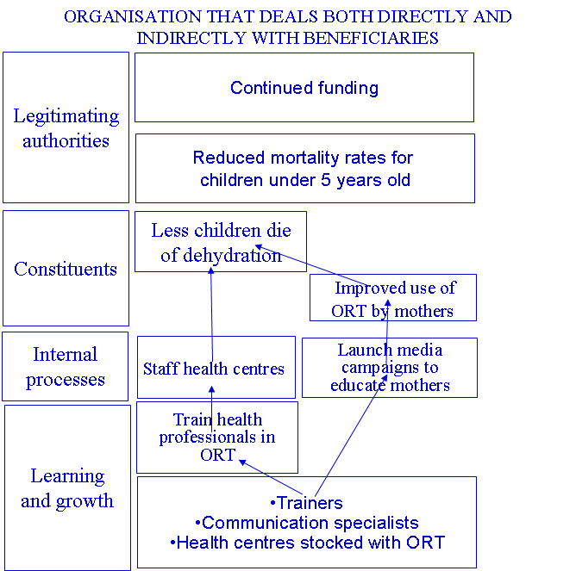

Mapping the intended logic of the various policy instruments used by an organisation allows to detect where instruments are possibly reinforcing each other or even working against each other. If all public organisations were to possess such maps, it would be useful to put the maps from organisations that are contributing to similar context objectives next to each other from time to time to see where there are possible synergies and contradictions. In this way, the BSC can be used for horizontal inter-departmental/agency coordination.

Coordinating multiple stakeholders
The BSC also allows to properly situate the many relevant stakeholders (see Figure 11) in an overall strategy, ensuring a coordinated approach towards them.
Figure 11: stakeholders in the BSC
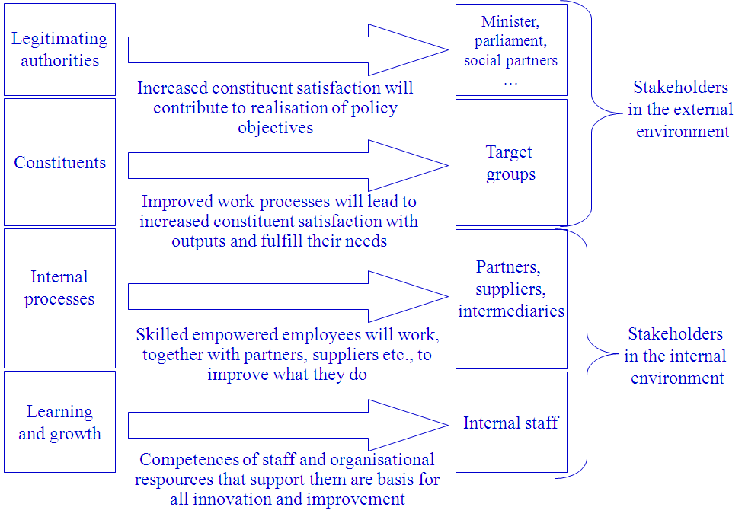

As was already stated, partners, suppliers and intermediate target groups are to be viewed as part of the internal environment as they are resources that can be mobilised by the public organisation. Their relative strengths and weaknesses are strengths and weaknesses for the public sector organisation as well. As such, they would show up in a SWOT analysis. However, the threats and opportunities in the SWOT arise from trends in the external environment. They have to do with changing needs of constituents as well as varying priorities of legitimising authorities.

It is important not to confuse partners, suppliers and intermediate target groups with constituents. While the former are crucial to improving the situation of the latter and therefore their capacity and willingness to collaborate must be sufficient, they are not to substitute the constituents. The BSC has the advantage to make this very clear by putting objectives towards them in the process perspective. On the other hand, this also ensures intermediate target groups etc. are not forgotten which could otherwise lead to losing a valuable resource all together.

In addition, it is also crucial to ensure that ministers, parliament, social partners etc. who have a legitimate stake in certain policy objectives as listed in the overall BSC legitimising authority perspective, do not take the managerial driving seat by telling the public organisation how to achieve objectives for final target groups. This would entail fixing objectives in all the different BSC perspectives, including in the process and learning and growth perspectives. However, legitimising authorities should limit themselves to putting forward objectives in the legitimising authority perspective, based on a country, regional or local analysis of needs, and, within that context, determine together with the public organisation within the constituent perspective which needs should be met to which extent.

Legitimising authorities are supposed to represent the needs of the entire population and not only that of specific target groups. That means that in setting overall policy objectives, trade-offs have already been made concerning competing needs of different target groups. However, once policy objectives have been set in the legitimising authority perspective, formulating outcomes or impacts and setting targets for specific target groups should be done in close collaboration with the groups that will be affected. This does not mean that legitimising authorities should not be able to also negotiate these objectives since they are the direct translation of the context objectives at the level of the public organisation. However, the public organisation should defend the position of the target groups as much as possible and involve them in doing this.

How the needs put forward by the legitimising authorities should be met is to be determined by the public organisation itself. Of course, the organisation will have to demonstrate that it is using a good approach. This will be further discussed in chapter 2.4.

Cascading strategy between hierarchical levels of the public organisation (vertical coordination)

Most public (and private) organisations have multiple levels of authority which we tend to refer to as “the hierarchy". In many cases the organisation is functional (e.g. organised by policy instruments), sometimes it is oriented towards different constituent groups (e.g. a department grouping all staff dealing with all instruments concerning the target group of Roma).

The high level corporate BSC may not be detailed enough for lower level units, let alone for individual staff members, to guide their day to day operations. To ensure it is really a tool to embed and manage strategy at all levels of the organisation, ensuring coordination between the different hierarchical levels of the public organisation (vertical coordination), the corporate BSC should be cascaded from higher to lower level units.

In order to do this, Nirmul (2003) affirms there are two basic approaches:
- either there will be a shared strategy set for different entities that do basically the same thing (e.g. different police zones in one country);
- or, it concerns contributories to an overall strategy where each entity takes care of a different aspect (e.g. the inspection versus the policy-making part of the Ministry of Transport) but contributes to the overall objective.

In the former case, BSCs will be similar for all units:
- legitimising authority perspective: here the same overall objectives will be found;
- constituent perspective: also a common set of objectives will be used;
- internal perspective: again a set of objectives common to all entities will be found but variations are possible among measures (not objectives) to reflect individual issues/weaknesses of different units;
- learning and growth: here there are usually differing needs so flexibility should be given while some minimum (e.g. certain fixed number of training days for all staff) conditions may still apply across the board.

In the case of contributories, only the objectives of the legitimising authority perspective will be common. Nirmul (2003) recommends that the overall BSC should focus on the junctures where the lower level BSCs link up.

Nirmul (2003) also specifies that there are commonly mixes of both types, referred to as “hybrid” maps.

The World Bank example is such a mix where the “campaigning department” and the “health professionals department” would both be supposed to contribute to the same common context objective but taking care of different aspects. However, they have more objectives in common than just the context objective as visualized by the shaded areas in Figure 12. The overall BSC therefore should make sure to retain those common objectives and to ensure that the various operational units use the same metrics for these. The theories of change underlying the overall corporate BSC’s also can become visible again at lower levels as is clear from the figure.

Figure 12: cascading in a mixed example
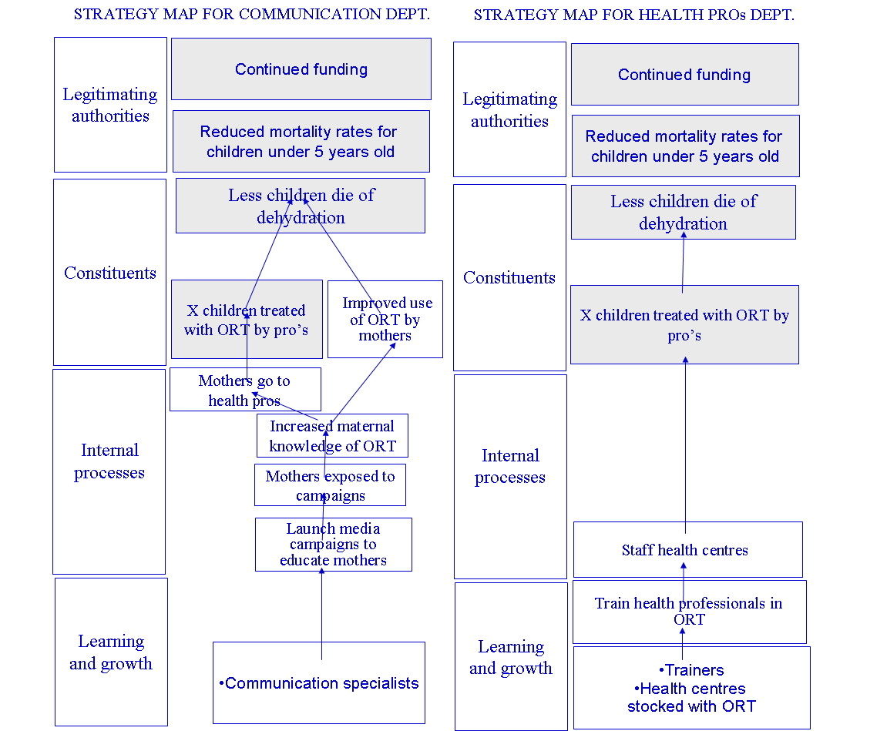

Cascading can even be used by individual staff to define objectives at their level. They can link personal action plans and objectives in the regular personnel planning exercises to the strategic objectives of the scorecard instead of trying to measure everything that is listed in their job descriptions.

In the personal planning exercise two types of targets can then be distinguished and linked to the BSC:
- for organisational improvement projects that target especially the “learning and growth” and “process” perspectives of the BSC, milestones are set that allow to track progress towards completion of the internal project. E.g. a project team is set up within the HR department to make sure that enough health professionals get adequately trained in ORT according to a pre-defined schedule. Each member of staff in this project team would know their role and planning e.g. finding and contracting trainers, etc.;
- individual targets for key strategic objectives that have been cascaded down from the overall BSC and that are therefore linked to ongoing business (in the process perspective) and support (in the learning and growth perspective) processes. E.g. if maintaining the level of competence in ORT at the various health centres is still seen as a key strategic objective, after initial capacity was built up, then the HR department would be held responsible for making sure this objective is realised. This entails that the HR department would, as part of their normal duties, regularly check competence levels, conduct extra training courses, hire qualified staff to replace some that left, move staff between health centres to cover short term shortages etc. Again here, those members of staff in the HR department that are responsible for these ongoing support processes should have relevant objectives in their personal plans e.g. if someone is in charge for keeping track of competence levels, they should have targets in their personal plans for how, when and where to conduct there tracking actions. If all members of staff have such plans, together they should have a good chance to achieve the unit BSC target to maintain certain levels of competence.

Organisational improvement projects are followed-up differently than regular processes:
- the former uses milestones to report on;
- the latter uses the targets as set for the (unit level) BSC objective; only when these targets are not being met sufficiently, would an investigation be launched as to the cause of this lack of achievement.

It is crucial to understand that BSCs should be strategic. Only objectives that are key to move closer to achieving constituent and legitimising authority expectations should be included. That means not all aspect of an individual staff member’s job will be tracked on the basis of the BSC, only those that are considered strategic. This means that appraising overall employee performance will still require other approaches. However, the BSC makes clear what is to be prioritised.

Linking strategic management and evaluation

If the BSC is drawn up as suggested in this article, managers would have used the BSC to determine ambition (what can the organisation be held responsible for because it is within the organisations’ control and what objectives can the organisation only influence, directly or indirectly) in agreement with the legitimising authority. Afterward, based on the BSC, managers at all levels should have regular reporting meetings. Smack (2003) proposes the following types of meetings:

- perspective reporting: progress in terms of one of the four perspectives (e.g. how are we looking towards all of our constituents) which allows for a comprehensive review of the entire BSC but will not cover cause-effects links across the BSC;
- theme reporting: progress across perspectives e.g. by focusing on a specific strategic theme (e.g. how are we doing with a particular policy instrument or a particular constituent group, across all four perspectives) which allows to discuss whether the linkages between objectives are correct but will not cover the entire BSC.
- exception based reporting: examining only objectives that are not meeting set expectations. This allows for short, focussed meetings but lacks comprehensiveness as well as a detailed discussion of causal links.

In addition, the BSC can be used to discuss:
- if the organisation is missing objectives or has wrong ones in the map;
- whether the organisation is using the right measures for the objectives.

These above meetings are clearly evaluative in nature. Kaplan and Norton (2000b) talk about single and double loop learning with the BSC as the way to ensure the use of the BSC as the managerial tool by excellence (see Figure 13).

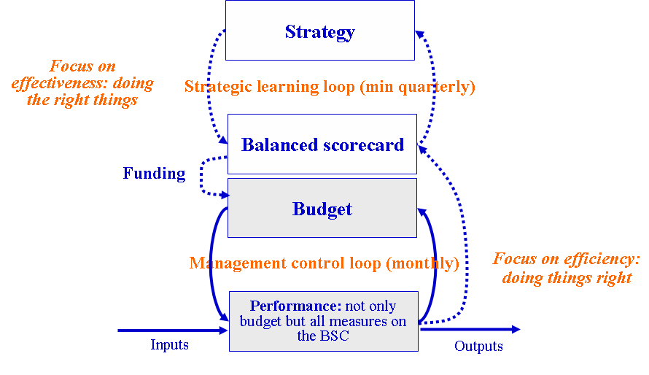
Figure 13: single and double loop learning with the BSC

The single loop refers to a (monthly) “management control” cycle where targets as included on the BSC are checked against realisation. This is therefore connected to the “exception based reporting meeting” defined earlier. The second (hence double) loop refers to “strategic” learning where the causal links as presumed in the BSC are assessed (on a quarterly basis). This is therefore connected to the theme reporting meetings, possibly in combination with perspective reporting meetings. Kaplan and Norton (2000b) refer to the first loop as focused on efficiency and the second one on effectiveness. To them, efficiency refers to just being on target, regardless whether this target is situated at output, outcome or impact level. Efficiency does not question the logic underlying these targets, only whether they are being met or not. Effectiveness, on the other hand, is more a matter of attribution: do the causal links as implied by the BSC indicators, from learning and growth to the legitimising authority perspective, actually prove to be correct.

Evaluators of public initiatives tend to use (variants of) the following criteria (adapted from EC, 2004):

- relevance: did the objectives that were set by the organisation really reflect the needs and problems of the targeted constituents?
- effectiveness: did the organisation deliver on the outputs and outcomes? Is this attributable to the organisation or not?
- impact: did the organisation obtain the impacts as planned? Can these be attributed to the organisation?
- efficiency: did the organisation convert its resources, by means of its processes to deliver its outputs? Were outputs achieved in a cost-efficient way (taking into account the costs for society as a whole)?
- sustainability: will the benefits obtained by beneficiaries be self-sustained or is ongoing activity necessary?

This is very close to the meaning of these terms as used by the BSC. There, effectiveness is also a question of attributing. If this is only with a view to support accountability, then mere attribution without understanding how the objectives were actually achieved is sufficient. Quantitative counterfactual evaluation approaches as promoted by the World Bank (see Khandker et al. 2010) are sufficient then. However, the BSC concept of the strategic learning loop implies evaluations that aim to research and substantiate the existence of assumed causal chains. Hence, this points to more sophisticated evaluation approaches mixing qualitative (such as case study approaches, see US GAO, 1990) and quantitative methods.In any case, it should be clear that project outcomes any impact should always be net effects, never gross.

Efficiency as understood by the BSC as judging whether input and output targets are being met in all BSC perspectives implies aspects of cost-efficiency as the BSC as a whole already contains expectations towards outputs and resources required and hence also implicit ratios.

In many cases, evaluators have to start from scratch when they are called to perform an evaluation. Whatever theories of change they produce, even if done in a participatory way, will always be labelled as “an evaluator thing” as producing a theory of change in an evaluation paper, then researching what happens in reality and then basing recommendations on this, does not ensure that an organisation will subsequently continue to use it as a strategic management tool. At best, some of the recommendations will be implemented but nothing much will happen until the next evaluation. The organisation will not put a clear understanding of what it aims to achieve and how it aims to do this at the core of its daily operation. With a proper BSC, evaluators have a good place to start assessing the performance of a public organisation but more importantly, the foundations of evaluative thinking are already embedded in the strategic management system of the organisation. This means staff members themselves will engage more regularly in evaluative actions. Indeed, indicators only provide a starting point for understanding what is going on and in many cases, staff members can through their contacts with stakeholders gain more insight in how things are really working. Of course, this does not imply the level of objectivity a formal evaluation can deliver. Evaluators can however build staff capacity in evaluative thinking and hence increase the likelihood that staff will ask the right questions when they are in contact with the field and hence gain valuable knowledge about how things are working in reality. This can feed into the quarterly strategic learning meetings alongside the indicator information.

Kaplan and Norton (2000b) also feature a link between the Balanced Scorecard and the budget. This link assumes that the organisation can change the allocation of funding when confronted with strategic learning (prompting to reallocate spending from current to new strategic priorities) or with operational variances (prompting to spend more or in a better way on the current strategic choices, to get back on track in reaching targets). This way of working can prove to be a cure for the “get rid of the budget” mentality that seems to be as pervasive in the public as in certain organisations in the private sector and that inevitably leads to waste.

In addition to conducting evaluations of completed interventions to feed strategic learning, evaluators can play an important role in setting up the BSC. They can help formulate the theories of change for instruments that will be deployed as well as propose the most appropriate indicators. This corresponds to an “evaluability assessment“ as described by EC (2007). In addition to formulating targets, evaluators could be used to conduct small scale, short term pilots or experiments that incorporate the essential elements of an intervention and that can therefore be used to assess the potential of such an intervention. Although the methods used will be similar to counterfactual impact evaluations (Khandker et al., 2010), the timing and scope will be different: rather than evaluating actual effects of (sometimes numerous) completed projects, experiments would be conducted ex ante in order to appraise potential and be able to set targets before large scale deployment is consuming public resources. This can then feed into a more informed target setting exercise. Of course, every time new policy objectives arrive on the scene or new interventions are devised, this should trigger management to revise the BSC, launching new evaluability assessments or experiments.

Using a BSC therefore fits well with Perrin’s (2002) concept of a principles approach to accountability (acting responsibly) rather than a compliance approach (following the rules, including meeting the targets). It is even stated that too much emphasis on accountability as compliance can lead to less, instead of more, responsibility. What is necessary to act responsibly is put forward by Perrin (2002) as follows: “programmes should be held accountable for demonstrating that they are asking the difficult questions, that they explicitly identify problems and limitations as well as what is going well, that they have in place appropriate monitoring systems and carry out evaluations looking at these challenging questions and issues. They should be held accountable for taking risky actions, rather than playing it safe….demonstrate that they not only do evaluations, but that they demonstrate what has been learned and that they act upon this information… One might well be sceptical of programmes that have met their stated objectives… This may well be an indication of objectives that were not very ambitious, of goal displacement, and/or of a failure to respond to changed circumstances. Objectives should be regularly reviewed and adjusted…so that they respond to changes in the environment…”

Kaplan et. al (2005) recommend to install an “Office of Strategy Management” (OSM) in every organisation that intends to make the most out of the BSC. This is supposed to perform the following functions:

- Create and oversee the strategic management system: help senior management to create the BSC, select performance targets and identify strategic initiatives (organisational improvement projects);
- Institutionalise the use of the BSC across the organisation, making sure that all units support the common strategy (and each other in the case of support units);
- Communicate the strategy e.g. through newsletters, CEO speeches etc.; coordinate with HR to ensure that skills necessary to the new strategic management system are acquired by staff;
- Review the strategy: organise and lead the reporting and review meetings, ensure that changes to the strategy are implemented in the corporate BSC and throughout the organisation;
- Refine the strategy: screen new strategic ideas coming from staff and stakeholders and convey promising ones to senior management;
- Manage strategic initiatives that cross unit lines and report progress to senior management;
- Consult with key strategy support functions:
  - Planning and budgeting: ensure that budgets reflect those established during the strategic planning process (e.g. strategic initiatives, reallocations of resources to new priorities)
  - HR: ensure HR manages employee incentives, competency development and annual reviews consistent to with strategic objectives
  - Knowledge management: ensure that best practices and ideas critical to the strategy are shared throughout the organisation.

As evaluation concepts are now at the core of the strategic management system of the public organisation, a useful approach may be to convert evaluation functions into an OSM as advocated above. Kaplan et. al (2005) state that the OSM will be most effective if it has direct access to the CEO and is placed on a par with the major functions such as finance, HR etc. They also state that the OSM does not need to be large. In the private sector, companies that have a turn-over of 500 million-5 billion USD and staff of 1000 to 10000 employees can get by with fewer than 10 people.

Case study: analysis of the strategy of the European Social Fund Agency of Flanders

The Flemish ESF Agency case

The case concerns the Flemish European Social Fund Agency. This is the agency that manages European Union (EU) funding for employment and social inclusion projects in the region of Flanders in Belgium. As the Agency is not currently using a BSC, it will not be possible to discuss how it is being used in practice, only to test whether the developed theoretical framework can be used to describe the (often implicit) strategy of a public sector organisation and, more specifically, an Agency that runs EU programmes.

The core business of this Agency is essentially selecting, funding and supporting projects to be carried out by other public, private and non-profit actors. To do this, the Agency launches calls for proposals. Intermediaries (e.g. the Flemish Employment Service) react to the calls with (sometimes very large) project proposals.

There are five priorities in this programme as described in a planning document that serves as a contract between the Agency and the European Commission, referred to as the “Operational Programme”:

- Talent activation and sustainable integration on the labour market
- Stimulating social inclusion
- Focussing the entrepreneurial and organisational culture on society
- Innovation
- Transnational and interregional cooperation

The first three are known as “mainstream” priorities that increase the level of funding available for regular labour market policy actions of the Flemish Government. Priority 4 and 5 both aim to support improvements to these regular policies through innovation and knowledge sharing across borders.

Next to the “Operational Programme” document, other objectives of the organisation can be derived from the “management contract” (service level agreement) between the Agency and the ministry of employment and social economy which also contains a variety of indicators.

In annex 1, the measures in this contract and their targets (if available) are listed alongside their reference number. Concerning the measures from the management contract, if the reference starts with M, this means there is no norm for this measure to which the management of the Agency can be held accountable, if it starts with D, there is a norm. In the same annex, the measures from the Operational Programme document are listed as OP and the numbers refers to the priority.

“Possible” objectives have been associated by the author of this paper with the measures, as for the majority of the measures in the two documents, there is no clear objective linked explicitly to the measure.

Coordinating multiple instruments and stakeholders

Annexes 2, 3 and 4 show theories of changes that have been adapted from a report drawn up by independent programme evaluators (De Peuter et. al, 2010). This report lists all the types of actions that were being financed by the Flemish ESF programme in the first half of the 2007-2014 programming period as well as tentative theories of change, derived from both interviews and workshops with stakeholders as well as scientific sources. The indicators as listed in the Operational Programme document provided a starting point for the evaluators. However, the exercise led the evaluators to think about plausible objectives connected to the indicators as well as substantially supplement these objectives with new ones. For example, in priority 1, the OP document did not contain any outcome indicator nor an associated objective for employed persons. Priority 3 also lacked any outcome indicators.

Annex 5 shows a simplified common model derived from the more detailed theories of change, using the guidelines put forward earlier in this paper. However, when applying these guidelines, it has to be clear that the ESF Agency does not influence the final target groups directly. Instead, it directly influences only intermediaries that respond to its calls for proposal and that get approved projects. Calls for proposals, monitoring actions etc. will be Agency output. The response of intermediaries to the Agency, including the delivery of project level outputs, will actually only be outcomes for the Agency (Agency only has direct influence on a project promoter but not control). Project level outcomes therefore will be Agency impact. For simplicity, the paper will refer to project level outcomes and impact.

It is important to stress that not all project level outcomes towards participants are outcomes towards final target groups. There are some outcomes that apply to the various projects’ own intermediate target groups e.g. in annex 2, actions that aim to change leadership styles are aimed at leaders, not directly at end beneficiaries. This draws attention to the problem noted earlier in this paper that logic model classifications of consequences are really action specific but that this is hard to visualise as some consequences are both outcomes and impacts because two different types of action are striving towards the same objective directly and indirectly.

The objectives that are retained in the reduced theory of change are, in compliance with the guidelines put forward earlier in this paper:
- direct outcomes for the Agency, being the outputs of the projects;
- impacts for the Agency, being the direct outcomes for the projects;
- final target group needs.

Of course, the picture is not complete as the Agency level outputs, activities and resources necessary to complete the BSC with process and learning and growth perspectives have not yet been described. In annex 6, all the objectives (including those implied from the service level agreement), have been placed in the full BSC framework as described earlier in this paper. This was done as follows:

- because even the reduced framework in annex 5 was too large to fit in an overall BSC, a further reduction of objectives had to be carried out in the constituent perspective: only final beneficiary needs were retained as distinct objectives while all other project level outcomes were summed up as “Projects are successful in reaching intended outcomes for target groups”. Within the constituent objective, satisfaction with project level outputs delivered directly to the final target groups are also listed as an aggregate;
- project level outputs and outcomes towards project level intermediate target groups are listed in the process perspective. For the Agency, when its direct intermediaries (project promoters) engage intermediate target groups, the latter still remain (indirect) intermediate target groups rather than become constituents. The map clearly shows the importance of the intermediaries as well as intermediate target groups in the process perspective. All of the yellow objectives in the process perspective tend to be objectives that need to be reached in order to secure the cooperation of the intermediaries. Without these intermediaries, nothing can be achieved by the ESF Agency. The intermediate target groups output and outcomes are also listed in the process perspective;
- the learning and growth perspective lists expectations concerning key Agency resources;
- finally, in the legitimising authority perspective we find various context objectives.

It will be clear that while the Agencies’ indicators and objectives may make little sense when considered in isolation such as in annex 1, placing them into the framework can make them more relevant to management and staff and provide for overall coordination between units, policy instruments as well as regarding stakeholders.

Concerning the latter, the ESF Agency has the following actors to take into account:

- Legitimising authority: the European Commission, the members of the Flemish programme monitoring committee charged with following up the execution of the programme (which includes social partners, ministers, government departments, etc.) and the board of the Agency (composed of partners that deliver some of the human resources of the Agency via secondments), charged with following up the running of the Agency as an organisation;
- Constituent perspective: final target groups both employed and unemployed with an emphasis on persons at a disadvantage in the labour market;
- Process perspective: project promoters and Agency staff;
- Learning and growth perspective: Agency staff.

The monitoring committee (including its sub-committees), as a body representing the legitimising authority, should ideally restrict itself to putting forward context objectives in the legitimising authority perspective and negotiating outcome or impact objectives concerning final target groups in the constituent perspective. Afterwards, it should follow-up performance regarding these objectives. As the only function of the Agency is to implement the ESF (and some other) programme(s), the traditional mandate of a board, i.e. to challenge the chief executive in terms of the strategy the organisation is following, would seem to overlap with that of the monitoring committee. However, in practice, the Board has tended to focus on the learning and growth perspective and some of the process perspective, while the monitoring committee focuses on some of the process perspective as well as the constituent perspective.

In order to take care actively of all stakeholders, as implied by the BSC, the Agency should not limit itself to engaging the Board and the monitoring committee regularly but should actively seek out target groups and intermediaries as well as these should, ideally, not be represented in this board or monitoring committee. This would upset the previously explained logic that legitimising authorities should represent the needs of the entire population and not only that of specific target groups. In translating overall policy objectives to the level of Agency, the Agency should however defend the position of the target groups as much as possible during the negotiations with the legitimising authorities.

As to intermediaries, the BSC, as stated earlier, clearly reflects their importance in the process perspective. To set these objectives, it is also recommended to engage intermediaries to find out what is really important to them. Of course, it should be remembered that intermediaries should be considered more as “subjects” than as clients, customers or citizens. Otherwise, the Agency would be like a teacher that gives all students a good grade to keep them satisfied. Hence, the Agency should expect the intermediary to want rules that are fair (to ensure intermediaries will not be disadvantaged relative to each other), reasons (rules that have a sound purpose and are reasonably implementable), clarity (unambiguous rules) and advice as made clear earlier in this paper.

After setting objectives linked to various stakeholders, it is of course also necessary to reflect on the issue of measurement. Clearly, the indicators contained in annex 1 sometimes need to be changed to fit better with a sensible objective. In relation to this, the issue is then where to find the information concerning these objectives. Learning and growth and most process information can be easily collected inside the Agency. However, some external process information needs to be collected from intermediaries (project promotors). The Agency already regularly conducts general satisfaction surveys among its promoters as well as end-of event surveys. The BSC can be a guide for the questions that are included in these surveys.

As to information concerning the satisfaction of both project level intermediate target groups and end-users with project outputs, this should be gained from them while they are still in contact with the project activities. The easiest way is to use subjective survey questions (using mainly opinion and attitude gauging rating scales) that are collected directly from participants via an Agency website or via paper forms to be sent to the Agency once the participants have received outputs according to project plans. If, for example, a target is set at programme level that 80% of participants in a training should be satisfied with (various elements of) the training (output measure), then when projects fall below that, they should be contacted to check what is happening. The same applies to direct outcomes that can be measured by simple scales e.g. asking to what extent participants agree they have acquired the level of knowledge that was set out before the training. This information can sometimes be collected with the same questionnaire as the one where satisfaction with the outputs is queried.

Using subjective measures has the advantage that they can be applicable to all interventions that are conducting actions that are listed in the theories of change (e.g. projects can be training participants to acquire very different competences, but a generic question can reveal to which degree this was successful, regardless of the nature of the competence). This makes it possible, at a relatively low cost, to see which projects (or actions in the project) perform better than others in terms of exerting the expected direct influence.

As soon as information cannot be collected anymore when participants are still in direct contact (e.g. because the objective is expected to take some time after participation to materialise), then the project or the ESF Agency can launch sample based surveys to find out from participants what happened after the direct project contact was finished. A more sophisticated version of this was presented in this paper in Table 1 where specific progress markers used to track progress in terms of changes in behaviour of boundary partners in specific projects were converted to generic indicators. Another possibility is to tap into central databases (e.g. concerning when person move into or out of employment) held by other parts of the public sector while making sure that privacy laws are respected.

However, the top-down approach to requesting data at project level to measure objectives as derived from the BSC conflicts with some of the calls for proposal launched by the Agency that are bottom-up in nature. This means that objectives are not predefined for projects, but that these projects, based on sound analysis and a participatory process, can define their own objectives and measures, as long as these will contribute to the call objectives. A solution to this is to run the top-down system that represents the overall logic of the call, in parallel to the bottom-up system that reflects a more detailed, project specific logic. Projects would only be required to report on indicators that are, within the call level theories of change, connected to actions the project intends to execute. E.g. a project that contains training actions should report on the level of satisfaction and the level of competence reached in accordance with the top down methodology of the Agency, while at the same time it should report on its own, self-defined indicators. The latter feeds into the project specific reporting system while the former feeds into the Agency BSC.

Costs implied by getting data regularly have to be compared to the practical use for the Agency. Monitoring data becomes less useful for discussing causal links across BSC maps the more outcomes and impacts are removed from the actions that are supposed to influence them. This is because a myriad of other influences will have affected these indicators. It may be wiser for the Agency to gather relevant data on these objectives only occasionally through evaluations rather than exhaust resources to gather data that is of little practical use. This is how evaluation becomes a key component of the strategic management system and will be addressed further in chapter 3.4.

Cascading the map

In the Flemish ESF Agency, there are currently four major departments. Once concerns project monitoring and control (operations). Another is charged with knowledge management. A third concerns support services (HR, secretariat, etc.) and a final one concerns quality labelling of promoter organisation. Each department should select those objectives from the overall BSC that it thinks it should contribute to and define additional others in relation to these. The advantage is that even though a unit will be responsible only for part of the objectives on the overall BSC, it will understand its place in the bigger picture and make this picture more operational by adding extra objectives relevant at its level.

In annex 7 a map cascaded to the level of the quality department is displayed. This department is also responsible for the overall quality management system of the Agency. Only objectives relevant for this department are left while leaving the causal logic clear through the four perspectives. In annex 8, a different map is produced when the overall map is cascaded to the level of those staff members working in the operations department. The theories of change connected to various policy instruments that are underlying the overall map become visible in detail again for this group of people.

Both maps can be used by individual members of staff to be linked with:

- their job description: some staff members in the group will be responsible for launching calls while others are responsible for processing payment claims, hence, they will have different objectives to realise as made clear from the map;
- organisational improvement actions: the objective “ensuring timely awareness of calls” can be linked to someone’s personal job description, but it is also possible that someone wants to conduct an internal project to improve performance on this objective for all colleagues e.g. by developing a new means of communication with intermediaries. This would then be labelled a strategic internal project. Milestones would be set to keep track of implementation.

Linking evaluation and strategic management

The overall map is able to allow senior managers to discuss three major overarching strategic concerns that run across the four perspectives:

- obtaining results for target groups
- making sure that expenditure complies with the rules
- ensuring swift progress is made in spending the funds.

The logic of “obtaining more results” runs roughly as follows. If we have competent and committed staff, who know what is expected of them, then they will be happy in their jobs, able to build the know-how and quality of promoters as well as launch calls for proposals that are appealing to promoters because they are made aware of them in a timely fashion, have clear rules and procedures and have a track-record of swift administrative processing (both in terms of (dis)approving proposals as well as disbursing the funds) and have involved key stakeholders to ensure their relevance. This will lead to satisfied and higher quality promoters who in turn will do their best to use the funds to reach out to the right target groups and to innovate for them (reflected in the objective of “capacity for delivery of better projects” which is linked to ESF call to develop innovative solutions for labour market problems that can be mainstreamed afterwards), satisfying their expectations. This, in combination with keeping costs reasonable, will lead to results, such as getting into a job, for more of the target groups. Finally, this contributes to increased employment rates and a whole range of more macro-economic effects as well a more positive image for the EU. The Agency hopes its mandate in a future programming period will be renewed if it does all of this.

“Regularity of expenditure” builds on the same Agency staff to help promoters to understand and apply the rules of ESF project management, ensuring their transparency. This will hopefully lead to compliance with EU rules. Together with compliance with Belgian rules for organisations, this again leads to a better image of (often criticised) spending of EU funding which the Agency hopes will also help to procure a continued mandate.

Finally, there is a focus on “swift spending”. This is due to the European Commission’s N+2 rule: funds must be spent by the Member State two years after commitment of the funds by the Commission according to a pre-set pattern or the funds must be returned to the Commission. The focal point of this theme is the objective “ensuring maximum use of available funds”. It is clearly very important for the legitimising stakeholders (the Flemish government who would lose the funding if it is not spent in a timely fashion) so it cannot be neglected. This does however not mean it should be addressed in the legitimising authority perspective as it is actually more a process objective. Indeed, our theoretical framework dictates that these kinds of operational issues should not be of concern to the legitimising authority at all. If the objectives in the constituent perspective are being achieved as expected, then why worry if not all available funds were spent to achieve them? It would therefore be a mistake to place it in the legitimising authority perspective.

Performance in the process perspective for the theme of “swift spending” again depends on the Agency staff supported by a good evidence base for managing the programme (dashboard, itself subject to quality management procedures) to be able to stick to deadlines and swiftly disburse the money. Since incorrectly or incompletely submitted project files also delay spending, the focus on spending needs to be combined with the focus on regularity of expenditure to be effective. This then allows to achieve the spending patterns as requested by the European Commission and to support more projects.

Next to using the three previous themes to discuss the map at corporate level, the map could also be segmented by coherent groups of policy instruments as reflected in the underlying theories of change. However, at the corporate level, only the objectives in the constituent perspective connected to final target group needs reflect the different policy instruments. It is therefore more useful to discuss performance along the lines of policy instruments by looking at the cascaded BSC’s as discussed earlier.

Apart from supporting the formulation of theories of change, evaluators can clearly help with (re)formulating the most appropriate indicators. This is not an exercise to be conducted for an ad hoc evaluation. This is core to setting up the strategic management system.

The same goes for setting targets. The Managing Authority should be able to invest in small scale experiments that are incorporating the most essential elements of existing or new policies in order to test the potential in terms of reaching outcomes.

Evaluation can afterwards also be used to help address what Perrin (2002) referred to earlier as “the difficult questions”. Indeed, when discussing cause-effect linkages across the BSC, senior managers will soon find that they require more information than what can actually be provided by looking at the indicators and discussing them during the reporting meetings. Usually, these will be questions concerning project level outcomes and impact that are too far removed from the actual financed actions for simple measures to be able to say anything about what has really been achieved. This is because indicator systems do not generally use counterfactuals to ensure that only net effects are reported. Yet the BSC should only contain net effects, never gross ones. As evaluators answer questions regarding some of the causal links within the BSC, this knowledge can be integrated immediately in the BSC: either links will turn out to be non-existent or very weak and may need to be dropped from the BSC map, or they turn out to be important. Decisions on reallocation of spending should take the existence of these current links into account.

Conclusion

This paper has put forward a generic framework that incorporates and/or is consistent with all of the major planning and evaluation tools currently at the disposal of all types of public sector organisation. It therefore allows to describe, and hence develop, public sector strategy in terms that are understood by both public sector managers and evaluators, as evidenced by the ESF Agency case. Therefore, following the framework as laid out in this article can allow strategy formulation and evaluation in the public sector to become two faces of the same strategic management coin, rather than separate, parallel exercises that do not add value to each other.

Annex 1: service level agreement between ESF Agency and Flemish Government

Reference | Measure/target | Possible objective
D1 | Yearly questionnaire to members of the Flemish Monitoring Committee (actual target still to be set) | Ensuring participation of stakeholders in the programme management
D2 | Availability of monitoring tables for the execution of the OP twice a year | Maintaining an evidence base for managing the programme
D3 | Availability of indicators concerning the objectives of the OP twice a year | Id.
D4 | a) Min 8 weeks period to submit proposals for a call + b) max 12 weeks to process proposals | a) ensuring sufficient time for intermediaries to participate b) ensuring certainty of funding in good time
D5 | a) 90% of payment requests to be treated in 90 calendar days + b) 90% of the treated files to be paid in 15 days | Making swift payments to intermediaries
D6 | Yearly survey of satisfaction rate of intermediaries (actual target still to be set) | Keeping intermediaries satisfied
D7 | Yearly growth rate of 10% on scores for intermediaries on the EFQM based quality label | Increasing organisational capacity of intermediary organisations to execute labour market actions
D8 | Yearly 50% women at level N2, 10% new recruits come from ethnic minority, 4% have handicap and “diversity” trainees from 2% of the total number of employees | Maintaining diversity of ESF staff
M1 | 3 monitoring committee meetings per year | Ensuring participation of stakeholders in the programme management
M2 | Yearly list of agenda points at monitoring committees is in compliance with monitoring committee jurisdiction | Id.
M3 | Number of calls launched per year | Swiftly (re)aligning the programme to the labour market conditions and demands
M4 | Number of projects analysed by three persons per year | Ensuring objectivity and expertise in proposal (dis)approval
M5 | Desk control of compliance of intermediaries with EU information and publicity rules | The image of Europe has improved
M6 | Number of meetings (with list of agenda points) between the different ESF authorities | Ensuring compliance with EU rules concerning management of the programme
M7 | Number of thematic work groups, meetings participants and products | Increasing level of expertise of actors concerning the labour market
M8 | Throughput time of payment requests without interruptions for requests for additional information | Swiftly processing payment requests
M9 | a) Number of files in process versus total number of files not yet finalised; b) number of files with interruptions for requests for additional information versus number of files in process | a) Swiftly processing of payment requests  b) Ensuring transparency (clearness and availability) of the rules concerning payments
M10 | Number of appeals and requests versus total number of processed files | Ensuring transparency (clearness and availability) of the rules concerning payments
M11 | Number of files that have been in process for more than 90 days | Making swift payments to intermediaries
M12 | Yearly independent audit report | Ensuring compliance with Belgian rules for non-profit organisations
M13 | Yearly number of communications on calls for proposals by channel, number of infosessions with number of participants | Ensuring timely awareness of calls
M14 | Yearly number of complaints by nature and consequences | Ensuring satisfaction of staff, intermediaries, target groups
M15 | Yearly number of knowledge dissemination events, by nature, nr of participants and evaluation scores | Increasing level of expertise of actors concerning the labour market
M16 | Yearly number of validated products | Capacity for delivery of (better) solutions to target groups has been increased
M17 | Yearly number of events of a technical nature (ESF management) for project promoters, by nature, nr of participants and evaluation scores | Professionalising intermediaries in ESF project management
M18 | Bi-annual survey of personnel about the workings of the Agency using the CAF model | Ensuring a permanent quality improvement system of the Agency
M19 | Yearly number of internal events for Agency staff, by nature, number of participants | Increasing expertise of staff
M20 | Bi-annual staff satisfaction survey | Ensuring staff satisfaction
M21 | Yearly nr of staff evaluations and planning sessions versus total number of staff | Setting clear expectations for staff
M22 | Yearly number of internal newsletters | Obtaining commitment of employees
OP 1 | 100% absorption of funding (bi-annual reporting) | Ensuring maximum use of available funds
OP 2 | Coverage of types of participants (no target) in terms of unemployed, employed, employers vs respective total population (bi-annual reporting) | Target groups (especially those most in need) have had appropriate access to solutions (quality projects)
OP 3 | Yearly budget % allocated to types of participants in terms of unemployed, employed, employers (no target) | Target groups (especially those most in need) have had appropriate access to solutions (quality projects)
OP 1.1 | Yearly coverage of priority target groups (e.g . age 50+) (% set as target) by quarter | Target groups (especially those most in need) have had appropriate access to solutions (quality projects)
OP 1.2 | Yearly average cost per action (in hours or heads) financed (no target) | Keeping cost per intervention to a reasonable level
OP 1.3 | Yearly number of persons leaving unemployment and going into work as % of total nr of participants (% targets set) immediately after action as well as 6 months after the action per quarter / Yearly number of persons moving from one action into another one, 3 months after action as % of total nr per quarter (% targets set) | More people got employed / People not in the regular labour market have moved closer to it
OP 1.4 | Number of persons moving into another job after a restructuring (no targets, no frequency) | Employed have stayed more in work
OP 1.5 | Quarterly/yearly number of working persons reached in heads (absolute target set) and hours split up in priority groups (with target on % of each group) | Target groups (especially those most in need) have had appropriate access to solutions (quality projects)
OP 1.6 | Quarterly reporting on number of persons reached for career guidance per year by priority groups (absolute target for whole + % for priority groups) | Target groups (especially those most in need) have had appropriate access to solutions (quality projects)
OP 1.7 | Id. for actions concerning validation of acquired competences (absolute target for total) | Target groups (especially those most in need) have had appropriate access to solutions (quality projects)
OP 2.1 | Yearly number of persons reached for work experience (absolute targets for 3 types of work experience) | Target groups (especially those most in need) have had appropriate access to solutions (quality projects)
OP 2.2 | Cost and duration of interventions (no target or frequency) | Keeping costs per intervention to a reasonable level
OP 2.3 | Yearly % of persons leaving unemployment for work 6 months after participation (% target by priority groups) | More people got employed
OP 3.1 | Number of organisations reached by type (no target or frequency) | Target groups (especially those most in need) have had appropriate access to solutions (quality projects)
OP 3.2 | Number of projects started (no target or frequency) | Target groups (especially those most in need) have had appropriate access to solutions (quality projects)
OP 4.1 | Number of projects started (no target or frequency) | Capacity for delivery of (better) solutions to target groups has been increased
OP 4.2 | Number of validated products (no target or frequency) | Capacity for delivery of (better) solutions to target groups has been increased
OP 5.1 | Number of projects started (no target or frequency) | Capacity for delivery of (better) solutions to target groups has been increased
OP 5.2 | Number of validated products (no target or frequency) | Capacity for delivery of (better) solutions to target groups has been increased

Annex 2 Theories of change linked to ESF instruments: actions towards employees within an organisational context

Annex 3: Theories of change linked to ESF instruments: actions towards employees independent of the organisational context

Annex 4: Theories of change linked to ESF instruments: actions towards unemployed

Annex 5: outcomes for the Balanced Scorecard for the Flemish ESF Agency

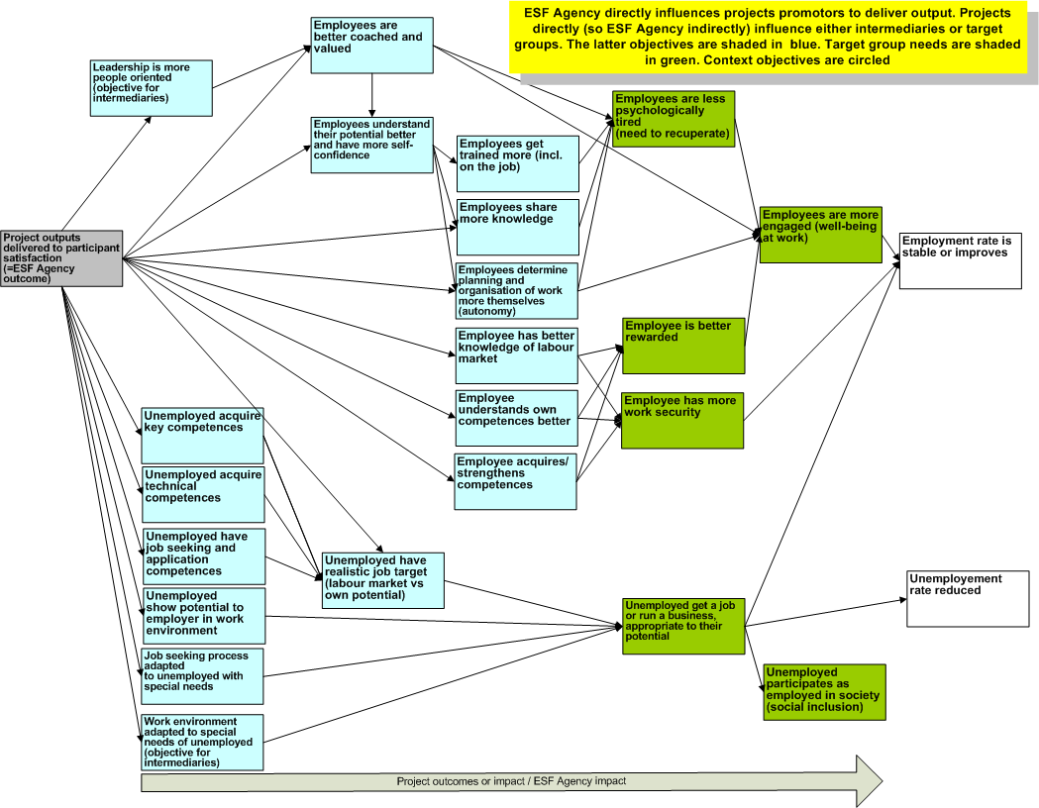
Annex 6: overall BSC for the Flemish ESF Agency

Annex 7: BSC cascaded to quality department

Annex 8: BSC cascaded to operations department, team dealing with actions for unemployed
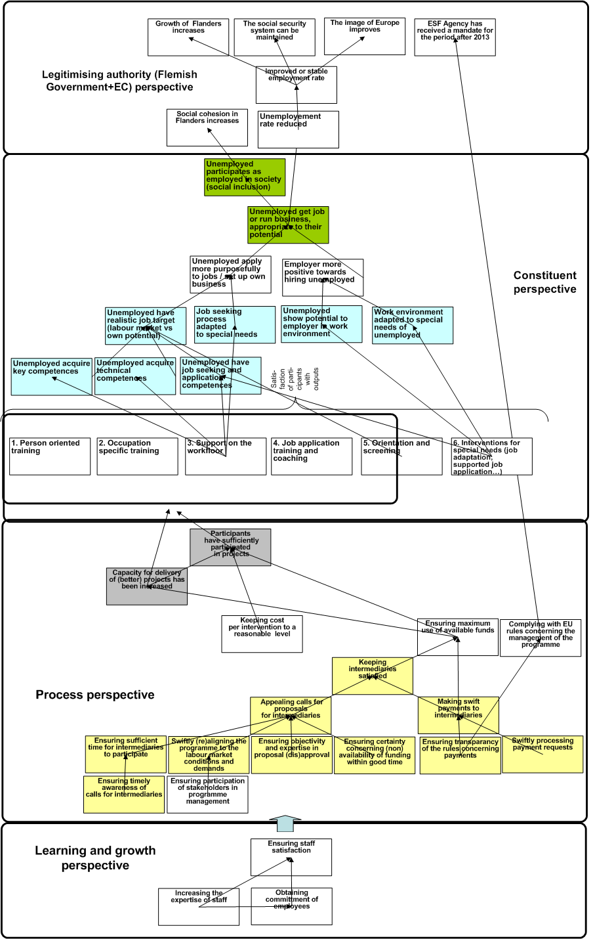

References

Adams C., Neely A. and Kennerley M. (2002) Performance prism: the scorecard for measuring and managing stakeholder relationships, London: Pearson

Chen H.T. (2005) Practical Program Evaluation: Assessing and Improving Planning, Implementation, and Effectiveness, London: Sage Publications

De Peuter B., Brans M., (2010) Naar verfijnde veranderingsmodellen als instrument voor de planning, opvolging en evaluatie van de ESF beleidspraktijk: Rapport bij de exploratieve fase van de midterm evaluatie (deelopdracht 2, Doorlopende evaluatie van het ESF Operationeel Programma 2007-2013) Leuven: Instituut voor de Overheid, K.U.Leuven

Epstein, M.J. and Wisner, P.S. (2001) 'Good neighbours: implementing social and environmental strategies with the BSC', Balanced Scorecard Report, vol. May-June, 8-11

Earl S., Carden F., Smutylo T. (2001) Outcome mapping : building learning and reflection into development programs , IRDC: Ottawa

European Commission (1999) MEANS Collection - Evaluation of socio-economic programmes, vol.1, Brussels: European Commission

European Commission (2004) Project cycle management guidelines, Brussels: European Commission

European Commission (2007) Evalsed: the resource for the evaluation of socio-economic development, Brussels: European Commission.

European Commission (2009) Impact assessment guidelines, Brussels: European Commission.

US GAO (1990) Case study evaluations, Washington: US GAO

Hax, A.C. and Wilde II, D.L (1999) 'The delta model: adaptive management for a changing world', Sloan Management Review, vol. winter, 11-28

Johnson G. and Scholes K. (eds.) (2000) Exploring public sector strategy, Essex: Pearson

Johnson G., Scholes K., Whittington R. (2008) Exploring Corporate Strategy, Essex: Pearson education limited

Kaplan, R.S. and Norton, D.P. (2000a) 'Having trouble with your strategy? Then map it', Harvard business review, vol. September-October, 167-176

Kaplan, R.S. and Norton, D.P. (2000b) 'Double-loop management: making strategy a continuous process' , Balanced scorecard report, vol. July-August , 1-4.

Kaplan, R.S. and Norton, D.P. (2001) The strategy focused organisation, Boston: Harvard Business School Press

Kaplan, R.S. and Norton, D.P. (2004) Strategy maps, Boston: Harvard Business School Press

Kaplan, R.S. and Norton, D.P. (2005) 'The Office of Strategy Management' , Harvard Business Review, vol. October 2005.

Kaplan, R.S. (2008) Strategy or Stakeholders: Which Comes First?, Balanced Scorecard Report, vol. March-April p. 14-16

Kelly G., Mulgan G. and Muers S. (2002) Creating public value, London: UK strategy unit, Cabinet Office

Khandker S.R., Koolwal G.B., Samad H.A. (2010) Handbook on Impact Evaluation: Quantitative Methods and Practices, Washington: World Bank

Kusek J.Z. and Rist R.C. (2004) Ten steps to a results-based monitoring and evaluation system, Washington: The International Bank for Reconstruction and Development /The World Bank

Lawrie G., Kalff D., Andersen H. (2005) Balanced Scorecard and Results-Based Management: convergent performance management systems, 3rd annual conference on performance measurement and management control, Paris

Maslow A. (1997), Motivation and personality, Hong Kong: Longman Asia Ltd

Montague S. (2000) Circles of influence, www.pmn.net, Performance Management Network Inc.

Mintzberg, H. (1996) 'Managing government, governing management', Harvard business review, vol. May-June, 75-83

Nirmul, A.G. (2003) 'Considerations on cascading BSC measures', Balanced scorecard report, vol. September- October, 14-16.

OECD/DAC (2002) Glossary of key terms in evaluation and results-based management, Paris: OECD/DAC

OECD (2009) Measuring government activity, Paris: OECD

Patton M.Q (1997) Utilization-Focused Evaluation: The New Century Text, California: Thousand Oaks

Perrin B. (2002) Towards a new view of accountability, European Evaluation Society conference, Seville.

Roduner D., Schläppi W., Egli W. (2008) Logical Framework Approach and Outcome Mapping: A Constructive Attempt of Synthesis, Zurich: AGRIDEA/NADEL/ ETH

Saldanha C.D. and Whittle J.F. (1998) Using the logical framework for sector analysis and project design: A user's guide, Asian Development Bank.

Solem R. R. (1987) 'The logical framework approach to project design, review and evaluation in A.I.D.: genesis, impact, problems, and opportunities', A.I.D. Working Paper No. 99, Washington : Center for Development Information & Evaluation Agency for International Development

Smack K. (2003) 'The How-to’s of BSC Reporting: the reporting meeting', Balanced scorecard report, vol. November- December, 3-.4

See Kaplan and Norton (2001) p.72-75 for a definition of mission and vision
Based on Adams C., Neely A. and Kennerley M. (2002), p. 251-252
Based on the value proposition of customer intimacy as detailed in Kaplan and Norton (2001), p. 86-95
Based on the “community” perspective in Adams C., Neely A. and Kennerley M. (2002), p. 342 without including the aspects of local skills and suppliers as these tend to be self-evident from a public sector perspective (employment in the public sector tends to be restricted to nationals and the same is often true for suppliers e.g. due to language and cultural barriers).
Based on the “regulator” gives and gets in Adams C., Neely A. and Kennerley M. (2002), p.341-342
A notable exception are system-lock in strategies where companies take advantage of network effects (the more other companies are enhancing a core offering, the more attractive it becomes e.g. Windows Operating System) and increasing marginal returns (the more a service is used, the more valuable it becomes e.g. Ebay) as detailed in Hax, A.C. and Wilde II, D.L (1999).
A detailed approach to stakeholder analysis can be found in Johnson G. and Scholes K. (2000), p. 165-184
This is not unlike distribution channels like supermarkets who serve as intermediaries for the offerings of production companies and who therefore need to be kept satisfied if the producer wants to reach consumers. On the other hand, the distributor also depends on the producer to fill its racks.

